Table of Contents

What is web? 3

What is W3C? 3

What is InterNet? 3

Comparing WAN Vs. LAN Vs. MAN 3

Some question and Answer 4

**HTML** 5

**Features of HTML** 6

Disadvantage of HTML 6

History of HTML 6

Note:- HTML is completely enclosed in tags. 6

What is tag? 6

Paired tags 6

Note:-The closing tag started with ‘/’. 7

Non Paired tags 7

Basic Structure of HTML 7

Working with HTML 8

Comments 8

Section in HTML 8

<meta/> tag 11

<style> 11

<script> 13

Body section 14

Note :- Noshade is working with only noshade not with color names. 18

**Figure 1 Basic Html Structure** 8

Figure 2 code to use faviconwhen image in same folder 10

Figure 3 Favicon image 1 10

Figure 4 code of favicon when image is in different folder 11

Figure 5 style web page 13

Figure 6 style code 13

Figure 11 Enitities web site 16

Figure 12 Heading code snip 16

Figure 13 Heading Website view 16

Figure 14 Paragraph web snip 17

Figure 15 Paragraph code 17

Figure 16 hr tag code 19

Figure 17 hr tag website snipt 19

Figure 19 form code 20

Figure 18 form web look 20

Figure 20 textarea web snipt 21

Figure 21 dropdown list web snipt 22

Figure 22 radio web snipt 22

Figure 23 checkbox web snipt 23

Figure 24 Legend and Fieldset web sinpt 1 23

Figure 25 Legend and Fieldset web sinpt 2 24

Figure 26 get web snipt 1 25

Figure 27 get web site snipt 2 25

Figure 28 post web snipt 1 26

Figure 29 post web snipt 2 26

# What is web?

* Collection of e resources connected electronically.
* Father of web is Tim Berners Lee

# What is W3C?

* World Wide Web consortium.
* It is a organization to maintain web standards.
* It is founded by Tim Berners Lee.
* 1st October 1994 at MIT LCS (Masschussests institute of technology Laboratory of computer Science).

# What is InterNet?

* International Network
* PAN (personal area network)
* Lan(Local area network)
* WAN (wide area Network)
* Internet
* Father of the internet is Dr. Vint Cerf.

## Comparing WAN Vs. LAN Vs. MAN

|  |  |  |
| --- | --- | --- |
| WAN | LAN | MAN |
| Wide Area Network | Local Area Network | Metropolitan Area Network |
| A WAN will typically cover a larger area geographically, such as a continent, a state or a country. | A LAN connects computers within a small and specific area geographically. | A MAN is confined to a specific town,  city or region. It covers a larger area  than a LAN but a smaller area than a  WAN. |
| For data transfer, there is low bandwidth. | For data transfer, there is high bandwidth. | For data transfer, there is a moderate  bandwidth. |
| It will typically have a distributed ownership model. | It is typically owned by an individual or an organization. | It can be owned publicly or privately. |
| A WAN network will have a larger coverage area that can range up to 100,000 KM and in some cases, stretches globally or over international borders. | A LAN network is limited to between 100-1000 meters coverage. | A MAN network is will usually stretch  up to an area of 100 KM. |
| It costs more to set-up a WAN than a LAN or a MAN. | It has a low cost of set-up. | It has a moderate cost of set-up. |
| With a WAN, you can get lower speeds of data transfer of 10-20 Mbps. | With a LAN, you can get higher speeds of data transfer with 10/100/1000 Mbps Ethernet (high speed). | With a MAN, you can get speeds of data  transfer up to 100 Mbps. |

# Some question and Answer

###### Difference between Markup and Programming language?

The main difference between markup language and programming language is that a markup language defines a set of rules for encoding documents in a format that is both human-readable and machine-readable while a programming language provides a set of commands and syntax that can be used to write computer programs which are understood by the computer.

A markup language is a type of language used to annotate text and embed tags in accurately styled electronic documents, irrespective of computer platforms, [operating systems](https://pediaa.com/difference-between-operating-system-and-application-software/#Operating%20System), applications or programs.  However, a programming language is a language that provides a set of rules, syntax, and commands to write computer programs that implements [algorithms](https://pediaa.com/difference-between-algorithm-and-pseudocode/#Algorithm).

###### Difference between Dynamic and static website?

|  |  |
| --- | --- |
| In static web pages, Pages will remain same until someone changes it manually. | In dynamic web pages, Content of pages are different for different visitors. |
| 2. | Static Web Pages are simple in terms of complexity. | Dynamic web pages are complicated. |
| 3. | In static web pages, Information are change rarely. | In dynamic web page, Information are change frequently. |
| 4. | Static Web Page takes less time for loading than dynamic web page. | Dynamic web page takes more time for loading. |
| 5. | In Static Web Pages, database is not used. | In dynamic web pages, database is used. |
| 6. | Static web pages are written in languages such as: HTML, JavaScript, CSS, etc. | Dynamic web pages are written in languages such as: CGI, AJAX, ASP, ASP.NET, etc. |
| 7. | Static web pages does not contain any application program . | Dynamic web pages contains application program for different services. |
| 8. | Static web pages require less work and cost in designing them. | Dynamic web pages require comparatively more work and cost in designing them. |

###### Why markup language is so dangerous?

Because we cannot find easily errors in markup language.

# **HTML**

* Hypertext Markup Language
* It is a standard markup language used to create static web pages.

# **Features of HTML**

* HTML is highly flexible and simple
* HTML is supported on almost every web browser.
* HTML is user friendly.

# Disadvantage of HTML

* It can create only static plain pages
* We need to write a lot of code for making simple page
* Security features of html are not good.

# History of HTML

* 1989 GML( Generalized Markup Language)
* 1991 SGML( Standard GML)
* 1994 HTML
* 2008 HTML5
* 2016 HTML 5.1

Note:- HTML is completely enclosed in tags.

# What is tag?

* Text placed between ‘<’ and ‘>’ is called as tag.
* E.G. <html>
* Types are classified into two types
  + Paired tags
  + Non-Paired tags

## Paired tags

* The tags that have both opening and closing tags are called as paired tags.

E.g. <html>

…

…

…

</html>

<body>

…

…

…

</body>

Note:-The closing tag started with ‘/’.

## Non Paired tags

* That tags that have only opening tag but no closing tag are called as non-paired tag.
* These tags are also called as
* Self-closed tags
* Forcefully closed tags
* Empty tags
* Singular tags

e.g

<br> or <br /> Break Tag(line Break)

<hr> or <hr /> Horizontal Rule(Horizontal Line)

<img> image tag

# Basic Structure of HTML

<html>

<head>

<title>….</title>

</head>

<body>

</body>

</html>

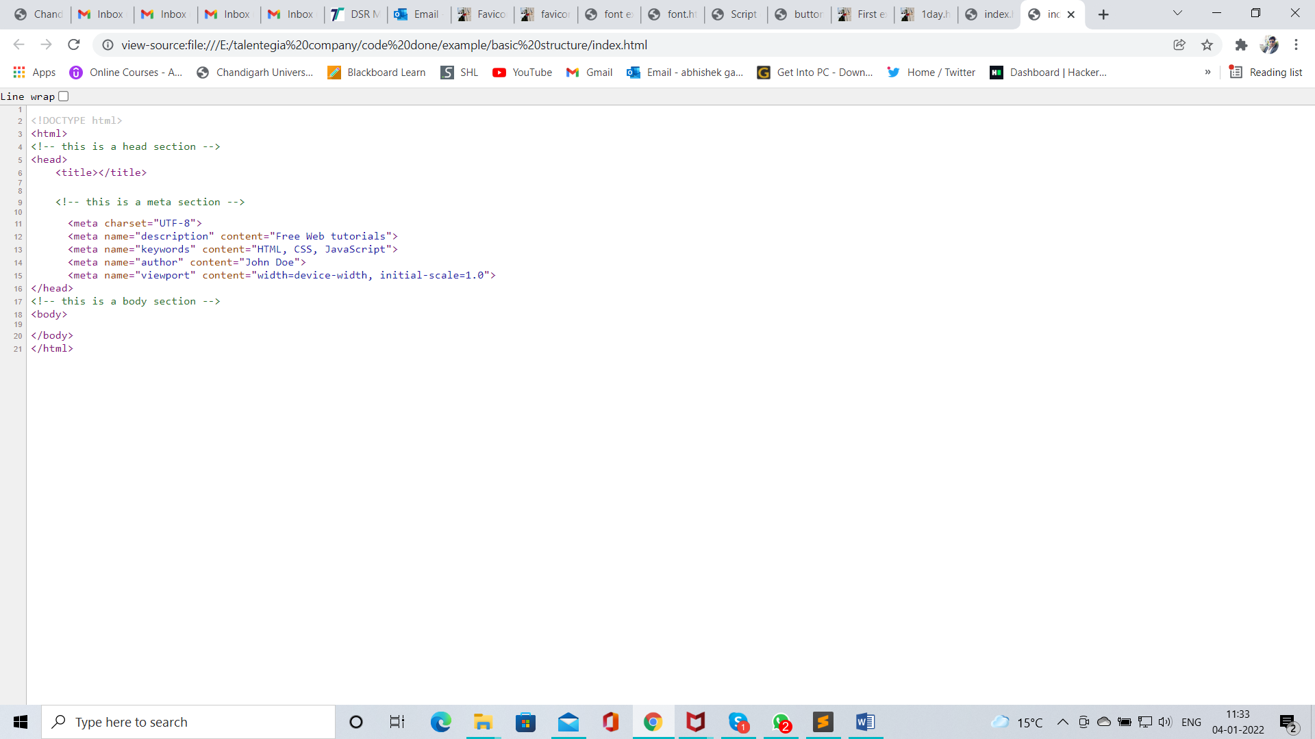

**Figure 1 Basic Html Structure**

## Working with HTML

* Open any text editor e.g. notepad, notepad++, sublime text, etc.
* Save this file with any name and extension ‘.html’
* Run above file in any web browser e.g. MS internet explorer, MS edge, Google chrome, MFF, Safari, Opera, UCB etc.
* Note :- HTML is case insensitive means A and a are same.

## HTML Element Reference

|  |  |  |
| --- | --- | --- |
| **Tag** | **Description** | |
| [<!--...-->](https://www.w3schools.com/tags/tag_comment.asp) | | Defines a comment |
| [<!DOCTYPE>](https://www.w3schools.com/tags/tag_doctype.asp) | | Defines the document type |
| [<a>](https://www.w3schools.com/tags/tag_a.asp) | | Defines a hyperlink |
| [<abbr>](https://www.w3schools.com/tags/tag_abbr.asp) | | Defines an abbreviation or an acronym |
| [<acronym>](https://www.w3schools.com/tags/tag_acronym.asp) | | Not supported in HTML5. Use [<abbr>](https://www.w3schools.com/tags/tag_abbr.asp) instead. Defines an acronym |
| [<address>](https://www.w3schools.com/tags/tag_address.asp) | | Defines contact information for the author/owner of a document |
| [<applet>](https://www.w3schools.com/tags/tag_applet.asp) | | Not supported in HTML5. Use [<embed>](https://www.w3schools.com/tags/tag_embed.asp) or [<object>](https://www.w3schools.com/tags/tag_object.asp) instead. Defines an embedded applet |
| [<area>](https://www.w3schools.com/tags/tag_area.asp) | | Defines an area inside an image map |
| [<article>](https://www.w3schools.com/tags/tag_article.asp) | | Defines an article |
| [<aside>](https://www.w3schools.com/tags/tag_aside.asp) | | Defines content aside from the page content |
| [<audio>](https://www.w3schools.com/tags/tag_audio.asp) | | Defines embedded sound content |
| [<b>](https://www.w3schools.com/tags/tag_b.asp) | | Defines bold text |
| [<base>](https://www.w3schools.com/tags/tag_base.asp) | | Specifies the base URL/target for all relative URLs in a document |
| [<basefont>](https://www.w3schools.com/tags/tag_basefont.asp) | | Not supported in HTML5. Use CSS instead. Specifies a default color, size, and font for all text in a document |
| [<bdi>](https://www.w3schools.com/tags/tag_bdi.asp) | | Isolates a part of text that might be formatted in a different direction from other text outside it |
| [<bdo>](https://www.w3schools.com/tags/tag_bdo.asp) | | Overrides the current text direction |
| [<big>](https://www.w3schools.com/tags/tag_big.asp) | | Not supported in HTML5. Use CSS instead. Defines big text |
| [<blockquote>](https://www.w3schools.com/tags/tag_blockquote.asp) | | Defines a section that is quoted from another source |
| [<body>](https://www.w3schools.com/tags/tag_body.asp) | | Defines the document's body |
| [<br>](https://www.w3schools.com/tags/tag_br.asp) | | Defines a single line break |
| [<button>](https://www.w3schools.com/tags/tag_button.asp) | | Defines a clickable button |
| [<canvas>](https://www.w3schools.com/tags/tag_canvas.asp) | | Used to draw graphics, on the fly, via scripting (usually JavaScript) |
| [<caption>](https://www.w3schools.com/tags/tag_caption.asp) | | Defines a table caption |
| [<center>](https://www.w3schools.com/tags/tag_center.asp) | | Not supported in HTML5. Use CSS instead. Defines centered text |
| [<cite>](https://www.w3schools.com/tags/tag_cite.asp) | | Defines the title of a work |
| [<code>](https://www.w3schools.com/tags/tag_code.asp) | | Defines a piece of computer code |
| [<col>](https://www.w3schools.com/tags/tag_col.asp) | | Specifies column properties for each column within a <colgroup> element |
| [<colgroup>](https://www.w3schools.com/tags/tag_colgroup.asp) | | Specifies a group of one or more columns in a table for formatting |
| [<data>](https://www.w3schools.com/tags/tag_data.asp) | | Adds a machine-readable translation of a given content |
| [<datalist>](https://www.w3schools.com/tags/tag_datalist.asp) | | Specifies a list of pre-defined options for input controls |
| [<dd>](https://www.w3schools.com/tags/tag_dd.asp) | | Defines a description/value of a term in a description list |
| [<del>](https://www.w3schools.com/tags/tag_del.asp) | | Defines text that has been deleted from a document |
| [<details>](https://www.w3schools.com/tags/tag_details.asp) | | Defines additional details that the user can view or hide |
| [<dfn>](https://www.w3schools.com/tags/tag_dfn.asp) | | Specifies a term that is going to be defined within the content |
| [<dialog>](https://www.w3schools.com/tags/tag_dialog.asp) | | Defines a dialog box or window |
| [<dir>](https://www.w3schools.com/tags/tag_dir.asp) | | Not supported in HTML5. Use [<ul>](https://www.w3schools.com/tags/tag_ul.asp) instead. Defines a directory list |
| [<div>](https://www.w3schools.com/tags/tag_div.asp) | | Defines a section in a document |
| [<dl>](https://www.w3schools.com/tags/tag_dl.asp) | | Defines a description list |
| [<dt>](https://www.w3schools.com/tags/tag_dt.asp) | | Defines a term/name in a description list |
| [<em>](https://www.w3schools.com/tags/tag_em.asp) | | Defines emphasized text |
| [<embed>](https://www.w3schools.com/tags/tag_embed.asp) | | Defines a container for an external application |
| [<fieldset>](https://www.w3schools.com/tags/tag_fieldset.asp) | | Groups related elements in a form |
| [<figcaption>](https://www.w3schools.com/tags/tag_figcaption.asp) | | Defines a caption for a <figure> element |
| [<figure>](https://www.w3schools.com/tags/tag_figure.asp) | | Specifies self-contained content |
| [<font>](https://www.w3schools.com/tags/tag_font.asp) | | Not supported in HTML5. Use CSS instead. Defines font, color, and size for text |
| [<footer>](https://www.w3schools.com/tags/tag_footer.asp) | | Defines a footer for a document or section |
| [<form>](https://www.w3schools.com/tags/tag_form.asp) | | Defines an HTML form for user input |
| [<frame>](https://www.w3schools.com/tags/tag_frame.asp) | | Not supported in HTML5. Defines a window (a frame) in a frameset |
| [<frameset>](https://www.w3schools.com/tags/tag_frameset.asp) | | Not supported in HTML5. Defines a set of frames |
| [<h1> to <h6>](https://www.w3schools.com/tags/tag_hn.asp) | | Defines HTML headings |
| [<head>](https://www.w3schools.com/tags/tag_head.asp) | | Contains metadata/information for the document |
| [<header>](https://www.w3schools.com/tags/tag_header.asp) | | Defines a header for a document or section |
| [<hr>](https://www.w3schools.com/tags/tag_hr.asp) | | Defines a thematic change in the content |
| [<html>](https://www.w3schools.com/tags/tag_html.asp) | | Defines the root of an HTML document |
| [<i>](https://www.w3schools.com/tags/tag_i.asp) | | Defines a part of text in an alternate voice or mood |
| [<iframe>](https://www.w3schools.com/tags/tag_iframe.asp) | | Defines an inline frame |
| [<img>](https://www.w3schools.com/tags/tag_img.asp) | | Defines an image |
| [<input>](https://www.w3schools.com/tags/tag_input.asp) | | Defines an input control |
| [<ins>](https://www.w3schools.com/tags/tag_ins.asp) | | Defines a text that has been inserted into a document |
| [<kbd>](https://www.w3schools.com/tags/tag_kbd.asp) | | Defines keyboard input |
| [<label>](https://www.w3schools.com/tags/tag_label.asp) | | Defines a label for an <input> element |
| [<legend>](https://www.w3schools.com/tags/tag_legend.asp) | | Defines a caption for a <fieldset> element |
| [<li>](https://www.w3schools.com/tags/tag_li.asp) | | Defines a list item |
| [<link>](https://www.w3schools.com/tags/tag_link.asp) | | Defines the relationship between a document and an external resource (most used to link to style sheets) |
| [<main>](https://www.w3schools.com/tags/tag_main.asp) | | Specifies the main content of a document |
| [<map>](https://www.w3schools.com/tags/tag_map.asp) | | Defines an image map |
| [<mark>](https://www.w3schools.com/tags/tag_mark.asp) | | Defines marked/highlighted text |
| [<meta>](https://www.w3schools.com/tags/tag_meta.asp) | | Defines metadata about an HTML document |
| [<meter>](https://www.w3schools.com/tags/tag_meter.asp) | | Defines a scalar measurement within a known range (a gauge) |
| [<nav>](https://www.w3schools.com/tags/tag_nav.asp) | | Defines navigation links |
| [<noframes>](https://www.w3schools.com/tags/tag_noframes.asp) | | Not supported in HTML5. Defines an alternate content for users that do not support frames |
| [<noscript>](https://www.w3schools.com/tags/tag_noscript.asp) | | Defines an alternate content for users that do not support client-side scripts |
| [<object>](https://www.w3schools.com/tags/tag_object.asp) | | Defines a container for an external application |
| [<ol>](https://www.w3schools.com/tags/tag_ol.asp) | | Defines an ordered list |
| [<optgroup>](https://www.w3schools.com/tags/tag_optgroup.asp) | | Defines a group of related options in a drop-down list |
| [<option>](https://www.w3schools.com/tags/tag_option.asp) | | Defines an option in a drop-down list |
| [<output>](https://www.w3schools.com/tags/tag_output.asp) | | Defines the result of a calculation |
| [<p>](https://www.w3schools.com/tags/tag_p.asp) | | Defines a paragraph |
| [<param>](https://www.w3schools.com/tags/tag_param.asp) | | Defines a parameter for an object |
| [<picture>](https://www.w3schools.com/tags/tag_picture.asp) | | Defines a container for multiple image resources |
| [<pre>](https://www.w3schools.com/tags/tag_pre.asp) | | Defines preformatted text |
| [<progress>](https://www.w3schools.com/tags/tag_progress.asp) | | Represents the progress of a task |
| [<q>](https://www.w3schools.com/tags/tag_q.asp) | | Defines a short quotation |
| [<rp>](https://www.w3schools.com/tags/tag_rp.asp) | | Defines what to show in browsers that do not support ruby annotations |
| [<rt>](https://www.w3schools.com/tags/tag_rt.asp) | | Defines an explanation/pronunciation of characters (for East Asian typography) |
| [<ruby>](https://www.w3schools.com/tags/tag_ruby.asp) | | Defines a ruby annotation (for East Asian typography) |
| [<s>](https://www.w3schools.com/tags/tag_s.asp) | | Defines text that is no longer correct |
| [<samp>](https://www.w3schools.com/tags/tag_samp.asp) | | Defines sample output from a computer program |
| [<script>](https://www.w3schools.com/tags/tag_script.asp) | | Defines a client-side script |
| [<section>](https://www.w3schools.com/tags/tag_section.asp) | | Defines a section in a document |
| [<select>](https://www.w3schools.com/tags/tag_select.asp) | | Defines a drop-down list |
| [<small>](https://www.w3schools.com/tags/tag_small.asp) | | Defines smaller text |
| [<source>](https://www.w3schools.com/tags/tag_source.asp) | | Defines multiple media resources for media elements (<video> and <audio>) |
| [<span>](https://www.w3schools.com/tags/tag_span.asp) | | Defines a section in a document |
| [<strike>](https://www.w3schools.com/tags/tag_strike.asp) | | Not supported in HTML5. Use [<del>](https://www.w3schools.com/tags/tag_del.asp) or [<s>](https://www.w3schools.com/tags/tag_s.asp) instead. Defines strikethrough text |
| [<strong>](https://www.w3schools.com/tags/tag_strong.asp) | | Defines important text |
| [<style>](https://www.w3schools.com/tags/tag_style.asp) | | Defines style information for a document |
| [<sub>](https://www.w3schools.com/tags/tag_sub.asp) | | Defines subscripted text |
| [<summary>](https://www.w3schools.com/tags/tag_summary.asp) | | Defines a visible heading for a <details> element |
| [<sup>](https://www.w3schools.com/tags/tag_sup.asp) | | Defines superscripted text |
| [<svg>](https://www.w3schools.com/tags/tag_svg.asp) | | Defines a container for SVG graphics |
| [<table>](https://www.w3schools.com/tags/tag_table.asp) | | Defines a table |
| [<tbody>](https://www.w3schools.com/tags/tag_tbody.asp) | | Groups the body content in a table |
| [<td>](https://www.w3schools.com/tags/tag_td.asp) | | Defines a cell in a table |
| [<template>](https://www.w3schools.com/tags/tag_template.asp) | | Defines a container for content that should be hidden when the page loads |
| [<textarea>](https://www.w3schools.com/tags/tag_textarea.asp) | | Defines a multiline input control (text area) |
| [<tfoot>](https://www.w3schools.com/tags/tag_tfoot.asp) | | Groups the footer content in a table |
| [<th>](https://www.w3schools.com/tags/tag_th.asp) | | Defines a header cell in a table |
| [<thead>](https://www.w3schools.com/tags/tag_thead.asp) | | Groups the header content in a table |
| [<time>](https://www.w3schools.com/tags/tag_time.asp) | | Defines a specific time (or datetime) |
| [<title>](https://www.w3schools.com/tags/tag_title.asp) | | Defines a title for the document |
| [<tr>](https://www.w3schools.com/tags/tag_tr.asp) | | Defines a row in a table |
| [<track>](https://www.w3schools.com/tags/tag_track.asp) | | Defines text tracks for media elements (<video> and <audio>) |
| [<tt>](https://www.w3schools.com/tags/tag_tt.asp) | | Not supported in HTML5. Use CSS instead. Defines teletype text |
| [<u>](https://www.w3schools.com/tags/tag_u.asp) | | Defines some text that is unarticulated and styled differently from normal text |
| [<ul>](https://www.w3schools.com/tags/tag_ul.asp) | | Defines an unordered list |
| [<var>](https://www.w3schools.com/tags/tag_var.asp) | | Defines a variable |
| [<video>](https://www.w3schools.com/tags/tag_video.asp) | | Defines embedded video content |
| [<wbr>](https://www.w3schools.com/tags/tag_wbr.asp) | | Defines a possible line-break |

## HTML Attribute Reference

|  |  |  |  |
| --- | --- | --- | --- |
| **Attribute** | **Belongs to** | | **scription** |
| [accept](https://www.w3schools.com/tags/att_accept.asp) | | [<input>](https://www.w3schools.com/tags/tag_input.asp) | Specifies the types of files that the server accepts (only for type="file") |
| [accept-charset](https://www.w3schools.com/tags/att_accept-charset.asp) | [<form>](https://www.w3schools.com/tags/tag_form.asp) | | Specifies the character encodings that are to be used for the form submission |
| [accesskey](https://www.w3schools.com/tags/att_accesskey.asp) | [Global Attributes](https://www.w3schools.com/tags/ref_standardattributes.asp) | | Specifies a shortcut key to activate/focus an element |
| [action](https://www.w3schools.com/tags/att_action.asp) | [<form>](https://www.w3schools.com/tags/tag_form.asp) | | Specifies where to send the form-data when a form is submitted |
| align | Not supported in HTML 5. | | Specifies the alignment according to surrounding elements. Use CSS instead |
| [alt](https://www.w3schools.com/tags/att_alt.asp) | [<area>](https://www.w3schools.com/tags/tag_area.asp), [<img>](https://www.w3schools.com/tags/tag_img.asp), [<input>](https://www.w3schools.com/tags/tag_input.asp) | | Specifies an alternate text when the original element fails to display |
| [async](https://www.w3schools.com/tags/att_async.asp) | [<script>](https://www.w3schools.com/tags/tag_script.asp) | | Specifies that the script is executed asynchronously (only for external scripts) |
| [autocomplete](https://www.w3schools.com/tags/att_autocomplete.asp) | [<form>](https://www.w3schools.com/tags/tag_form.asp), [<input>](https://www.w3schools.com/tags/tag_input.asp) | | Specifies whether the <form> or the <input> element should have autocomplete enabled |
| [autofocus](https://www.w3schools.com/tags/att_autofocus.asp) | [<button>](https://www.w3schools.com/tags/tag_button.asp), [<input>](https://www.w3schools.com/tags/tag_input.asp), [<select>](https://www.w3schools.com/tags/tag_select.asp), [<textarea>](https://www.w3schools.com/tags/tag_textarea.asp) | | Specifies that the element should automatically get focus when the page loads |
| [autoplay](https://www.w3schools.com/tags/att_autoplay.asp) | [<audio>](https://www.w3schools.com/tags/tag_audio.asp), [<video>](https://www.w3schools.com/tags/tag_video.asp) | | Specifies that the audio/video will start playing as soon as it is ready |
| bgcolor | Not supported in HTML 5. | | Specifies the background color of an element. Use CSS instead |
| border | Not supported in HTML 5. | | Specifies the width of the border of an element. Use CSS instead |
| [charset](https://www.w3schools.com/tags/att_charset.asp) | [<meta>](https://www.w3schools.com/tags/tag_meta.asp), [<script>](https://www.w3schools.com/tags/tag_script.asp) | | Specifies the character encoding |
| [checked](https://www.w3schools.com/tags/att_checked.asp) | [<input>](https://www.w3schools.com/tags/tag_input.asp) | | Specifies that an <input> element should be pre-selected when the page loads (for type="checkbox" or type="radio") |
| [cite](https://www.w3schools.com/tags/att_cite.asp) | <blockquote>, [<del>](https://www.w3schools.com/tags/tag_del.asp), [<ins>](https://www.w3schools.com/tags/tag_ins.asp), <q> | | Specifies a URL which explains the quote/deleted/inserted text |
| [class](https://www.w3schools.com/tags/att_class.asp) | [Global Attributes](https://www.w3schools.com/tags/ref_standardattributes.asp) | | Specifies one or more classnames for an element (refers to a class in a style sheet) |
| color | Not supported in HTML 5. | | Specifies the text color of an element. Use CSS instead |
| [cols](https://www.w3schools.com/tags/att_cols.asp) | [<textarea>](https://www.w3schools.com/tags/tag_textarea.asp) | | Specifies the visible width of a text area |
| [colspan](https://www.w3schools.com/tags/att_colspan.asp) | [<td>](https://www.w3schools.com/tags/tag_td.asp), [<th>](https://www.w3schools.com/tags/tag_th.asp) | | Specifies the number of columns a table cell should span |
| [content](https://www.w3schools.com/tags/att_content.asp) | [<meta>](https://www.w3schools.com/tags/tag_meta.asp) | | Gives the value associated with the http-equiv or name attribute |
| [contenteditable](https://www.w3schools.com/tags/att_contenteditable.asp) | [Global Attributes](https://www.w3schools.com/tags/ref_standardattributes.asp) | | Specifies whether the content of an element is editable or not |
| [controls](https://www.w3schools.com/tags/att_controls.asp) | [<audio>](https://www.w3schools.com/tags/tag_audio.asp), [<video>](https://www.w3schools.com/tags/tag_video.asp) | | Specifies that audio/video controls should be displayed (such as a play/pause button etc) |
| [coords](https://www.w3schools.com/tags/att_coords.asp) | [<area>](https://www.w3schools.com/tags/tag_area.asp) | | Specifies the coordinates of the area |
| [data](https://www.w3schools.com/tags/att_data.asp) | [<object>](https://www.w3schools.com/tags/tag_object.asp) | | Specifies the URL of the resource to be used by the object |
| [data-*](https://www.w3schools.com/tags/att_data-.asp) | [Global Attributes](https://www.w3schools.com/tags/ref_standardattributes.asp) | | Used to store custom data private to the page or application |
| [datetime](https://www.w3schools.com/tags/att_datetime.asp) | [<del>](https://www.w3schools.com/tags/tag_del.asp), [<ins>](https://www.w3schools.com/tags/tag_ins.asp), [<time>](https://www.w3schools.com/tags/tag_time.asp) | | Specifies the date and time |
| [default](https://www.w3schools.com/tags/att_default.asp) | [<track>](https://www.w3schools.com/tags/tag_track.asp) | | Specifies that the track is to be enabled if the user's preferences do not indicate that another track would be more appropriate |
| [defer](https://www.w3schools.com/tags/att_defer.asp) | [<script>](https://www.w3schools.com/tags/tag_script.asp) | | Specifies that the script is executed when the page has finished parsing (only for external scripts) |
| [dir](https://www.w3schools.com/tags/att_dir.asp) | [Global Attributes](https://www.w3schools.com/tags/ref_standardattributes.asp) | | Specifies the text direction for the content in an element |
| [dirname](https://www.w3schools.com/tags/att_dirname.asp) | [<input>](https://www.w3schools.com/tags/tag_input.asp), [<textarea>](https://www.w3schools.com/tags/tag_textarea.asp) | | Specifies that the text direction will be submitted |
| [disabled](https://www.w3schools.com/tags/att_disabled.asp) | [<button>](https://www.w3schools.com/tags/tag_button.asp), [<fieldset>](https://www.w3schools.com/tags/tag_fieldset.asp), [<input>](https://www.w3schools.com/tags/tag_input.asp), <optgroup>, [<option>](https://www.w3schools.com/tags/tag_option.asp), [<select>](https://www.w3schools.com/tags/tag_select.asp), [<textarea>](https://www.w3schools.com/tags/tag_textarea.asp) | | Specifies that the specified element/group of elements should be disabled |
| [download](https://www.w3schools.com/tags/att_download.asp) | [<a>](https://www.w3schools.com/tags/tag_a.asp), [<area>](https://www.w3schools.com/tags/tag_area.asp) | | Specifies that the target will be downloaded when a user clicks on the hyperlink |
| [draggable](https://www.w3schools.com/tags/att_draggable.asp) | [Global Attributes](https://www.w3schools.com/tags/ref_standardattributes.asp) | | Specifies whether an element is draggable or not |
| [enctype](https://www.w3schools.com/tags/att_enctype.asp) | [<form>](https://www.w3schools.com/tags/tag_form.asp) | | Specifies how the form-data should be encoded when submitting it to the server (only for method="post") |
| [for](https://www.w3schools.com/tags/att_for.asp) | <label>, [<output>](https://www.w3schools.com/tags/tag_output.asp) | | Specifies which form element(s) a label/calculation is bound to |
| [form](https://www.w3schools.com/tags/att_form.asp) | [<button>](https://www.w3schools.com/tags/tag_button.asp), [<fieldset>](https://www.w3schools.com/tags/tag_fieldset.asp), [<input>](https://www.w3schools.com/tags/tag_input.asp), <label>, [<meter>](https://www.w3schools.com/tags/tag_meter.asp), [<object>](https://www.w3schools.com/tags/tag_object.asp), [<output>](https://www.w3schools.com/tags/tag_output.asp), [<select>](https://www.w3schools.com/tags/tag_select.asp), [<textarea>](https://www.w3schools.com/tags/tag_textarea.asp) | | Specifies the name of the form the element belongs to |
| [formaction](https://www.w3schools.com/tags/att_formaction.asp) | [<button>](https://www.w3schools.com/tags/tag_button.asp), [<input>](https://www.w3schools.com/tags/tag_input.asp) | | Specifies where to send the form-data when a form is submitted. Only for type="submit" |
| [headers](https://www.w3schools.com/tags/att_headers.asp) | [<td>](https://www.w3schools.com/tags/tag_td.asp), [<th>](https://www.w3schools.com/tags/tag_th.asp) | | Specifies one or more headers cells a cell is related to |
| [height](https://www.w3schools.com/tags/att_height.asp) | <canvas>, [<embed>](https://www.w3schools.com/tags/tag_embed.asp), [<iframe>](https://www.w3schools.com/tags/tag_iframe.asp), [<img>](https://www.w3schools.com/tags/tag_img.asp), [<input>](https://www.w3schools.com/tags/tag_input.asp), [<object>](https://www.w3schools.com/tags/tag_object.asp), [<video>](https://www.w3schools.com/tags/tag_video.asp) | | Specifies the height of the element |
| [hidden](https://www.w3schools.com/tags/att_hidden.asp) | [Global Attributes](https://www.w3schools.com/tags/ref_standardattributes.asp) | | Specifies that an element is not yet, or is no longer, relevant |
| [high](https://www.w3schools.com/tags/att_high.asp) | [<meter>](https://www.w3schools.com/tags/tag_meter.asp) | | Specifies the range that is considered to be a high value |
| [href](https://www.w3schools.com/tags/att_href.asp) | [<a>](https://www.w3schools.com/tags/tag_a.asp), [<area>](https://www.w3schools.com/tags/tag_area.asp), [<base>](https://www.w3schools.com/tags/tag_base.asp), [<link>](https://www.w3schools.com/tags/tag_link.asp) | | Specifies the URL of the page the link goes to |
| [hreflang](https://www.w3schools.com/tags/att_hreflang.asp) | [<a>](https://www.w3schools.com/tags/tag_a.asp), [<area>](https://www.w3schools.com/tags/tag_area.asp), [<link>](https://www.w3schools.com/tags/tag_link.asp) | | Specifies the language of the linked document |
| [http-equiv](https://www.w3schools.com/tags/att_http-equiv.asp) | [<meta>](https://www.w3schools.com/tags/tag_meta.asp) | | Provides an HTTP header for the information/value of the content attribute |
| [id](https://www.w3schools.com/tags/att_id.asp) | [Global Attributes](https://www.w3schools.com/tags/ref_standardattributes.asp) | | Specifies a unique id for an element |
| [ismap](https://www.w3schools.com/tags/att_ismap.asp) | [<img>](https://www.w3schools.com/tags/tag_img.asp) | | Specifies an image as a server-side image map |
| [kind](https://www.w3schools.com/tags/att_kind.asp) | [<track>](https://www.w3schools.com/tags/tag_track.asp) | | Specifies the kind of text track |
| [label](https://www.w3schools.com/tags/att_label.asp) | [<track>](https://www.w3schools.com/tags/tag_track.asp), [<option>](https://www.w3schools.com/tags/tag_option.asp), [<optgroup>](https://www.w3schools.com/tags/tag_optgroup.asp) | | Specifies the title of the text track |
| [lang](https://www.w3schools.com/tags/att_lang.asp) | [Global Attributes](https://www.w3schools.com/tags/ref_standardattributes.asp) | | Specifies the language of the element's content |
| [list](https://www.w3schools.com/tags/att_list.asp) | [<input>](https://www.w3schools.com/tags/tag_input.asp) | | Refers to a <datalist> element that contains pre-defined options for an <input> element |
| [loop](https://www.w3schools.com/tags/att_loop.asp) | [<audio>](https://www.w3schools.com/tags/tag_audio.asp), [<video>](https://www.w3schools.com/tags/tag_video.asp) | | Specifies that the audio/video will start over again, every time it is finished |
| [low](https://www.w3schools.com/tags/att_low.asp) | [<meter>](https://www.w3schools.com/tags/tag_meter.asp) | | Specifies the range that is considered to be a low value |
| [max](https://www.w3schools.com/tags/att_max.asp) | [<input>](https://www.w3schools.com/tags/tag_input.asp), [<meter>](https://www.w3schools.com/tags/tag_meter.asp), [<progress>](https://www.w3schools.com/tags/tag_progress.asp) | | Specifies the maximum value |
| [maxlength](https://www.w3schools.com/tags/att_maxlength.asp) | [<input>](https://www.w3schools.com/tags/tag_input.asp), [<textarea>](https://www.w3schools.com/tags/tag_textarea.asp) | | Specifies the maximum number of characters allowed in an element |
| [media](https://www.w3schools.com/tags/att_media.asp) | [<a>](https://www.w3schools.com/tags/tag_a.asp), [<area>](https://www.w3schools.com/tags/tag_area.asp), [<link>](https://www.w3schools.com/tags/tag_link.asp), [<source>](https://www.w3schools.com/tags/tag_source.asp), [<style>](https://www.w3schools.com/tags/tag_style.asp) | | Specifies what media/device the linked document is optimized for |
| [method](https://www.w3schools.com/tags/att_method.asp) | [<form>](https://www.w3schools.com/tags/tag_form.asp) | | Specifies the HTTP method to use when sending form-data |
| [min](https://www.w3schools.com/tags/att_min.asp) | [<input>](https://www.w3schools.com/tags/tag_input.asp), [<meter>](https://www.w3schools.com/tags/tag_meter.asp) | | Specifies a minimum value |
| [multiple](https://www.w3schools.com/tags/att_multiple.asp) | [<input>](https://www.w3schools.com/tags/tag_input.asp), [<select>](https://www.w3schools.com/tags/tag_select.asp) | | Specifies that a user can enter more than one value |
| [muted](https://www.w3schools.com/tags/att_muted.asp) | [<video>](https://www.w3schools.com/tags/tag_video.asp), [<audio>](https://www.w3schools.com/tags/tag_audio.asp) | | Specifies that the audio output of the video should be muted |
| [name](https://www.w3schools.com/tags/att_name.asp) | [<button>](https://www.w3schools.com/tags/tag_button.asp), [<fieldset>](https://www.w3schools.com/tags/tag_fieldset.asp), [<form>](https://www.w3schools.com/tags/tag_form.asp), [<iframe>](https://www.w3schools.com/tags/tag_iframe.asp), [<input>](https://www.w3schools.com/tags/tag_input.asp), [<map>](https://www.w3schools.com/tags/tag_map.asp), [<meta>](https://www.w3schools.com/tags/tag_meta.asp), [<object>](https://www.w3schools.com/tags/tag_object.asp), [<output>](https://www.w3schools.com/tags/tag_output.asp), [<param>](https://www.w3schools.com/tags/tag_param.asp), [<select>](https://www.w3schools.com/tags/tag_select.asp), [<textarea>](https://www.w3schools.com/tags/tag_textarea.asp) | | Specifies the name of the element |
| [novalidate](https://www.w3schools.com/tags/att_novalidate.asp) | [<form>](https://www.w3schools.com/tags/tag_form.asp) | | Specifies that the form should not be validated when submitted |
| [onabort](https://www.w3schools.com/tags/att_onabort.asp) | [<audio>](https://www.w3schools.com/tags/tag_audio.asp), [<embed>](https://www.w3schools.com/tags/tag_embed.asp), [<img>](https://www.w3schools.com/tags/tag_img.asp), [<object>](https://www.w3schools.com/tags/tag_object.asp), [<video>](https://www.w3schools.com/tags/tag_video.asp) | | Script to be run on abort |
| [onafterprint](https://www.w3schools.com/tags/att_onafterprint.asp) | [<body>](https://www.w3schools.com/tags/tag_body.asp) | | Script to be run after the document is printed |
| [onbeforeprint](https://www.w3schools.com/tags/att_onbeforeprint.asp) | [<body>](https://www.w3schools.com/tags/tag_body.asp) | | Script to be run before the document is printed |
| [onbeforeunload](https://www.w3schools.com/tags/att_onbeforeunload.asp) | [<body>](https://www.w3schools.com/tags/tag_body.asp) | | Script to be run when the document is about to be unloaded |
| [onblur](https://www.w3schools.com/tags/att_onblur.asp) | All visible elements. | | Script to be run when the element loses focus |
| [oncanplay](https://www.w3schools.com/tags/att_oncanplay.asp) | [<audio>](https://www.w3schools.com/tags/tag_audio.asp), [<embed>](https://www.w3schools.com/tags/tag_embed.asp), [<object>](https://www.w3schools.com/tags/tag_object.asp), [<video>](https://www.w3schools.com/tags/tag_video.asp) | | Script to be run when a file is ready to start playing (when it has buffered enough to begin) |
| [oncanplaythrough](https://www.w3schools.com/tags/att_oncanplaythrough.asp) | [<audio>](https://www.w3schools.com/tags/tag_audio.asp), [<video>](https://www.w3schools.com/tags/tag_video.asp) | | Script to be run when a file can be played all the way to the end without pausing for buffering |
| [onchange](https://www.w3schools.com/tags/att_onchange.asp) | All visible elements. | | Script to be run when the value of the element is changed |
| [onclick](https://www.w3schools.com/tags/att_onclick.asp) | All visible elements. | | Script to be run when the element is being clicked |
| [oncontextmenu](https://www.w3schools.com/tags/att_oncontextmenu.asp) | All visible elements. | | Script to be run when a context menu is triggered |
| [oncopy](https://www.w3schools.com/tags/att_oncopy.asp) | All visible elements. | | Script to be run when the content of the element is being copied |
| [oncuechange](https://www.w3schools.com/tags/att_oncuechange.asp) | [<track>](https://www.w3schools.com/tags/tag_track.asp) | | Script to be run when the cue changes in a [<track>](https://www.w3schools.com/tags/tag_track.asp) element |
| [oncut](https://www.w3schools.com/tags/att_oncut.asp) | All visible elements. | | Script to be run when the content of the element is being cut |
| [ondblclick](https://www.w3schools.com/tags/att_ondblclick.asp) | All visible elements. | | Script to be run when the element is being double-clicked |
| [ondrag](https://www.w3schools.com/tags/att_ondrag.asp) | All visible elements. | | Script to be run when the element is being dragged |
| [ondragend](https://www.w3schools.com/tags/att_ondragend.asp) | All visible elements. | | Script to be run at the end of a drag operation |
| [ondragenter](https://www.w3schools.com/tags/att_ondragenter.asp) | All visible elements. | | Script to be run when an element has been dragged to a valid drop target |
| [ondragleave](https://www.w3schools.com/tags/att_ondragleave.asp) | All visible elements. | | Script to be run when an element leaves a valid drop target |
| [ondragover](https://www.w3schools.com/tags/att_ondragover.asp) | All visible elements. | | Script to be run when an element is being dragged over a valid drop target |
| [ondragstart](https://www.w3schools.com/tags/att_ondragstart.asp) | All visible elements. | | Script to be run at the start of a drag operation |
| [ondrop](https://www.w3schools.com/tags/att_ondrop.asp) | All visible elements. | | Script to be run when dragged element is being dropped |
| [ondurationchange](https://www.w3schools.com/tags/att_ondurationchange.asp) | [<audio>](https://www.w3schools.com/tags/tag_audio.asp), [<video>](https://www.w3schools.com/tags/tag_video.asp) | | Script to be run when the length of the media changes |
| [onemptied](https://www.w3schools.com/tags/att_onemptied.asp) | [<audio>](https://www.w3schools.com/tags/tag_audio.asp), [<video>](https://www.w3schools.com/tags/tag_video.asp) | | Script to be run when something bad happens and the file is suddenly unavailable (like unexpectedly disconnects) |
| [onended](https://www.w3schools.com/tags/att_onended.asp) | [<audio>](https://www.w3schools.com/tags/tag_audio.asp), [<video>](https://www.w3schools.com/tags/tag_video.asp) | | Script to be run when the media has reach the end (a useful event for messages like "thanks for listening") |
| [onerror](https://www.w3schools.com/tags/att_onerror.asp) | [<audio>](https://www.w3schools.com/tags/tag_audio.asp), [<body>](https://www.w3schools.com/tags/tag_body.asp), [<embed>](https://www.w3schools.com/tags/tag_embed.asp), [<img>](https://www.w3schools.com/tags/tag_img.asp), [<object>](https://www.w3schools.com/tags/tag_object.asp), [<script>](https://www.w3schools.com/tags/tag_script.asp), [<style>](https://www.w3schools.com/tags/tag_style.asp), [<video>](https://www.w3schools.com/tags/tag_video.asp) | | Script to be run when an error occurs |
| [onfocus](https://www.w3schools.com/tags/att_onfocus.asp) | All visible elements. | | Script to be run when the element gets focus |
| [onhashchange](https://www.w3schools.com/tags/att_onhashchange.asp) | [<body>](https://www.w3schools.com/tags/tag_body.asp) | | Script to be run when there has been changes to the anchor part of the a URL |
| [oninput](https://www.w3schools.com/tags/att_oninput.asp) | All visible elements. | | Script to be run when the element gets user input |
| [oninvalid](https://www.w3schools.com/tags/att_oninvalid.asp) | All visible elements. | | Script to be run when the element is invalid |
| [onkeydown](https://www.w3schools.com/tags/att_onkeydown.asp) | All visible elements. | | Script to be run when a user is pressing a key |
| [onkeypress](https://www.w3schools.com/tags/att_onkeypress.asp) | All visible elements. | | Script to be run when a user presses a key |
| [onkeyup](https://www.w3schools.com/tags/att_onkeyup.asp) | All visible elements. | | Script to be run when a user releases a key |
| [onload](https://www.w3schools.com/tags/att_onload.asp) | [<body>](https://www.w3schools.com/tags/tag_body.asp), [<iframe>](https://www.w3schools.com/tags/tag_iframe.asp), [<img>](https://www.w3schools.com/tags/tag_img.asp), [<input>](https://www.w3schools.com/tags/tag_input.asp), [<link>](https://www.w3schools.com/tags/tag_link.asp), [<script>](https://www.w3schools.com/tags/tag_script.asp), [<style>](https://www.w3schools.com/tags/tag_style.asp) | | Script to be run when the element is finished loading |
| [onloadeddata](https://www.w3schools.com/tags/att_onloadeddata.asp) | [<audio>](https://www.w3schools.com/tags/tag_audio.asp), [<video>](https://www.w3schools.com/tags/tag_video.asp) | | Script to be run when media data is loaded |
| [onloadedmetadata](https://www.w3schools.com/tags/att_onloadedmetadata.asp) | [<audio>](https://www.w3schools.com/tags/tag_audio.asp), [<video>](https://www.w3schools.com/tags/tag_video.asp) | | Script to be run when meta data (like dimensions and duration) are loaded |
| [onloadstart](https://www.w3schools.com/tags/att_onloadstart.asp) | [<audio>](https://www.w3schools.com/tags/tag_audio.asp), [<video>](https://www.w3schools.com/tags/tag_video.asp) | | Script to be run just as the file begins to load before anything is actually loaded |
| [onmousedown](https://www.w3schools.com/tags/att_onmousedown.asp) | All visible elements. | | Script to be run when a mouse button is pressed down on an element |
| [onmousemove](https://www.w3schools.com/tags/att_onmousemove.asp) | All visible elements. | | Script to be run as long as the  mouse pointer is moving over an element |
| [onmouseout](https://www.w3schools.com/tags/att_onmouseout.asp) | All visible elements. | | Script to be run when a mouse pointer moves out of an element |
| [onmouseover](https://www.w3schools.com/tags/att_onmouseover.asp) | All visible elements. | | Script to be run when a mouse pointer moves over an element |
| [onmouseup](https://www.w3schools.com/tags/att_onmouseup.asp) | All visible elements. | | Script to be run when a mouse button is released over an element |
| [onmousewheel](https://www.w3schools.com/tags/att_onmousewheel.asp) | All visible elements. | | Script to be run when a mouse wheel is being scrolled over an element |
| [onoffline](https://www.w3schools.com/tags/att_onoffline.asp) | [<body>](https://www.w3schools.com/tags/tag_body.asp) | | Script to be run when the browser starts to work offline |
| [ononline](https://www.w3schools.com/tags/att_ononline.asp) | [<body>](https://www.w3schools.com/tags/tag_body.asp) | | Script to be run when the browser starts to work online |
| onpagehide | [<body>](https://www.w3schools.com/tags/tag_body.asp) | | Script to be run when a user navigates away from a page |
| [onpageshow](https://www.w3schools.com/tags/att_onpageshow.asp) | [<body>](https://www.w3schools.com/tags/tag_body.asp) | | Script to be run when a user navigates to a page |
| [onpaste](https://www.w3schools.com/tags/att_onpaste.asp) | All visible elements. | | Script to be run when the user pastes some content in an element |
| [onpause](https://www.w3schools.com/tags/att_onpause.asp) | [<audio>](https://www.w3schools.com/tags/tag_audio.asp), [<video>](https://www.w3schools.com/tags/tag_video.asp) | | Script to be run when the media is paused either by the user or programmatically |
| [onplay](https://www.w3schools.com/tags/att_onplay.asp) | [<audio>](https://www.w3schools.com/tags/tag_audio.asp), [<video>](https://www.w3schools.com/tags/tag_video.asp) | | Script to be run when the media has started playing |
| [onplaying](https://www.w3schools.com/tags/att_onplaying.asp) | [<audio>](https://www.w3schools.com/tags/tag_audio.asp), [<video>](https://www.w3schools.com/tags/tag_video.asp) | | Script to be run when the media has started playing |
| onpopstate | [<body>](https://www.w3schools.com/tags/tag_body.asp) | | Script to be run when the window's history changes. |
| [onprogress](https://www.w3schools.com/tags/att_onprogress.asp) | [<audio>](https://www.w3schools.com/tags/tag_audio.asp), [<video>](https://www.w3schools.com/tags/tag_video.asp) | | Script to be run when the browser is in the process of getting the media data |
| [onratechange](https://www.w3schools.com/tags/att_onratechange.asp) | [<audio>](https://www.w3schools.com/tags/tag_audio.asp), [<video>](https://www.w3schools.com/tags/tag_video.asp) | | Script to be run each time the playback rate changes (like when a user switches to a slow motion or fast forward mode). |
| [onreset](https://www.w3schools.com/tags/att_onreset.asp) | [<form>](https://www.w3schools.com/tags/tag_form.asp) | | Script to be run when a reset button in a form is clicked. |
| [onresize](https://www.w3schools.com/tags/att_onresize.asp) | [<body>](https://www.w3schools.com/tags/tag_body.asp) | | Script to be run when the browser window is being resized. |
| [onscroll](https://www.w3schools.com/tags/att_onscroll.asp) | All visible elements. | | Script to be run when an element's scrollbar is being scrolled |
| [onsearch](https://www.w3schools.com/tags/att_onsearch.asp) | [<input>](https://www.w3schools.com/tags/tag_input.asp) | | Script to be run when the user writes something in a search field (for <input="search">) |
| [onseeked](https://www.w3schools.com/tags/att_onseeked.asp) | [<audio>](https://www.w3schools.com/tags/tag_audio.asp), [<video>](https://www.w3schools.com/tags/tag_video.asp) | | Script to be run when the seeking attribute is set to false indicating that seeking has ended |
| [onseeking](https://www.w3schools.com/tags/att_onseeking.asp) | [<audio>](https://www.w3schools.com/tags/tag_audio.asp), [<video>](https://www.w3schools.com/tags/tag_video.asp) | | Script to be run when the seeking attribute is set to true indicating that seeking is active |
| [onselect](https://www.w3schools.com/tags/att_onselect.asp) | All visible elements. | | Script to be run when the element gets selected |
| [onstalled](https://www.w3schools.com/tags/att_onstalled.asp) | [<audio>](https://www.w3schools.com/tags/tag_audio.asp), [<video>](https://www.w3schools.com/tags/tag_video.asp) | | Script to be run when the browser is unable to fetch the media data for whatever reason |
| onstorage | [<body>](https://www.w3schools.com/tags/tag_body.asp) | | Script to be run when a Web Storage area is updated |
| [onsubmit](https://www.w3schools.com/tags/att_onsubmit.asp) | [<form>](https://www.w3schools.com/tags/tag_form.asp) | | Script to be run when a form is submitted |
| [onsuspend](https://www.w3schools.com/tags/att_onsuspend.asp) | [<audio>](https://www.w3schools.com/tags/tag_audio.asp), [<video>](https://www.w3schools.com/tags/tag_video.asp) | | Script to be run when fetching the media data is stopped before it is completely loaded for whatever reason |
| [ontimeupdate](https://www.w3schools.com/tags/att_ontimeupdate.asp) | [<audio>](https://www.w3schools.com/tags/tag_audio.asp), [<video>](https://www.w3schools.com/tags/tag_video.asp) | | Script to be run when the playing position has changed (like when the user fast forwards to a different point in the media) |
| [ontoggle](https://www.w3schools.com/tags/att_ontoggle.asp) | [<details>](https://www.w3schools.com/tags/tag_details.asp) | | Script to be run when the user opens or closes the <details> element |
| [onunload](https://www.w3schools.com/tags/att_onunload.asp) | [<body>](https://www.w3schools.com/tags/tag_body.asp) | | Script to be run when a page has unloaded (or the browser window has been closed) |
| [onvolumechange](https://www.w3schools.com/tags/att_onvolumechange.asp) | [<audio>](https://www.w3schools.com/tags/tag_audio.asp), [<video>](https://www.w3schools.com/tags/tag_video.asp) | | Script to be run each time the volume of a video/audio has been changed |
| [onwaiting](https://www.w3schools.com/tags/att_onwaiting.asp) | [<audio>](https://www.w3schools.com/tags/tag_audio.asp), [<video>](https://www.w3schools.com/tags/tag_video.asp) | | Script to be run when the media has paused but is expected to resume (like when the media pauses to buffer more data) |
| [onwheel](https://www.w3schools.com/tags/att_onwheel.asp) | All visible elements. | | Script to be run when the mouse wheel rolls up or down over an element |
| [open](https://www.w3schools.com/tags/att_open.asp) | [<details>](https://www.w3schools.com/tags/tag_details.asp) | | Specifies that the details should be visible (open) to the user |
| [optimum](https://www.w3schools.com/tags/att_optimum.asp) | [<meter>](https://www.w3schools.com/tags/tag_meter.asp) | | Specifies what value is the optimal value for the gauge |
| [pattern](https://www.w3schools.com/tags/att_pattern.asp) | [<input>](https://www.w3schools.com/tags/tag_input.asp) | | Specifies a regular expression that an <input> element's value is checked against |
| [placeholder](https://www.w3schools.com/tags/att_placeholder.asp) | [<input>](https://www.w3schools.com/tags/tag_input.asp), [<textarea>](https://www.w3schools.com/tags/tag_textarea.asp) | | Specifies a short hint that describes the expected value of the element |
| [poster](https://www.w3schools.com/tags/att_poster.asp) | [<video>](https://www.w3schools.com/tags/tag_video.asp) | | Specifies an image to be shown while the video is downloading, or until the user hits the play button |
| [preload](https://www.w3schools.com/tags/att_preload.asp) | [<audio>](https://www.w3schools.com/tags/tag_audio.asp), [<video>](https://www.w3schools.com/tags/tag_video.asp) | | Specifies if and how the author thinks the audio/video should be loaded when the page loads |
| [readonly](https://www.w3schools.com/tags/att_readonly.asp) | [<input>](https://www.w3schools.com/tags/tag_input.asp), [<textarea>](https://www.w3schools.com/tags/tag_textarea.asp) | | Specifies that the element is read-only |
| [rel](https://www.w3schools.com/tags/att_rel.asp) | [<a>](https://www.w3schools.com/tags/tag_a.asp), [<area>](https://www.w3schools.com/tags/tag_area.asp), [<form>](https://www.w3schools.com/tags/tag_form.asp), [<link>](https://www.w3schools.com/tags/tag_link.asp) | | Specifies the relationship between the current document and the linked document |
| [required](https://www.w3schools.com/tags/att_required.asp) | [<input>](https://www.w3schools.com/tags/tag_input.asp), [<select>](https://www.w3schools.com/tags/tag_select.asp), [<textarea>](https://www.w3schools.com/tags/tag_textarea.asp) | | Specifies that the element must be filled out before submitting the form |
| [reversed](https://www.w3schools.com/tags/att_reversed.asp) | [<ol>](https://www.w3schools.com/tags/tag_ol.asp) | | Specifies that the list order should be descending (9,8,7...) |
| [rows](https://www.w3schools.com/tags/att_rows.asp) | [<textarea>](https://www.w3schools.com/tags/tag_textarea.asp) | | Specifies the visible number of lines in a text area |
| [rowspan](https://www.w3schools.com/tags/att_rowspan.asp) | [<td>](https://www.w3schools.com/tags/tag_td.asp), [<th>](https://www.w3schools.com/tags/tag_th.asp) | | Specifies the number of rows a table cell should span |
| [sandbox](https://www.w3schools.com/tags/att_sandbox.asp) | [<iframe>](https://www.w3schools.com/tags/tag_iframe.asp) | | Enables an extra set of restrictions for the content in an <iframe> |
| [scope](https://www.w3schools.com/tags/att_scope.asp) | [<th>](https://www.w3schools.com/tags/tag_th.asp) | | Specifies whether a header cell is a header for a column, row, or group of columns or rows |
| [selected](https://www.w3schools.com/tags/att_selected.asp) | [<option>](https://www.w3schools.com/tags/tag_option.asp) | | Specifies that an option should be pre-selected when the page loads |
| [shape](https://www.w3schools.com/tags/att_shape.asp) | [<area>](https://www.w3schools.com/tags/tag_area.asp) | | Specifies the shape of the area |
| [size](https://www.w3schools.com/tags/att_size.asp) | [<input>](https://www.w3schools.com/tags/tag_input.asp), [<select>](https://www.w3schools.com/tags/tag_select.asp) | | Specifies the width, in characters (for <input>) or specifies the number of visible options (for <select>) |
| [sizes](https://www.w3schools.com/tags/att_sizes.asp) | [<img>](https://www.w3schools.com/tags/tag_img.asp), [<link>](https://www.w3schools.com/tags/tag_link.asp), [<source>](https://www.w3schools.com/tags/tag_source.asp) | | Specifies the size of the linked resource |
| [span](https://www.w3schools.com/tags/att_span.asp) | [<col>](https://www.w3schools.com/tags/tag_col.asp), [<colgroup>](https://www.w3schools.com/tags/tag_colgroup.asp) | | Specifies the number of columns to span |
| [spellcheck](https://www.w3schools.com/tags/att_spellcheck.asp) | [Global Attributes](https://www.w3schools.com/tags/ref_standardattributes.asp) | | Specifies whether the element is to have its spelling and grammar checked or not |
| [src](https://www.w3schools.com/tags/att_src.asp) | [<audio>](https://www.w3schools.com/tags/tag_audio.asp), [<embed>](https://www.w3schools.com/tags/tag_embed.asp), [<iframe>](https://www.w3schools.com/tags/tag_iframe.asp), [<img>](https://www.w3schools.com/tags/tag_img.asp), [<input>](https://www.w3schools.com/tags/tag_input.asp), [<script>](https://www.w3schools.com/tags/tag_script.asp), [<source>](https://www.w3schools.com/tags/tag_source.asp), [<track>](https://www.w3schools.com/tags/tag_track.asp), [<video>](https://www.w3schools.com/tags/tag_video.asp) | | Specifies the URL of the media file |
| [srcdoc](https://www.w3schools.com/tags/att_srcdoc.asp) | [<iframe>](https://www.w3schools.com/tags/tag_iframe.asp) | | Specifies the HTML content of the page to show in the <iframe> |
| [srclang](https://www.w3schools.com/tags/att_srclang.asp) | [<track>](https://www.w3schools.com/tags/tag_track.asp) | | Specifies the language of the track text data (required if kind="subtitles") |
| [srcset](https://www.w3schools.com/tags/att_source_srcset.asp) | [<img>](https://www.w3schools.com/tags/tag_img.asp), [<source>](https://www.w3schools.com/tags/tag_source.asp) | | Specifies the URL of the image to use in different situations |
| [start](https://www.w3schools.com/tags/att_start.asp) | [<ol>](https://www.w3schools.com/tags/tag_ol.asp) | | Specifies the start value of an ordered list |
| [step](https://www.w3schools.com/tags/att_step.asp) | [<input>](https://www.w3schools.com/tags/tag_input.asp) | | Specifies the legal number intervals for an input field |
| [style](https://www.w3schools.com/tags/att_style.asp) | [Global Attributes](https://www.w3schools.com/tags/ref_standardattributes.asp) | | Specifies an inline CSS style for an element |
| [tabindex](https://www.w3schools.com/tags/att_tabindex.asp) | [Global Attributes](https://www.w3schools.com/tags/ref_standardattributes.asp) | | Specifies the tabbing order of an element |
| [target](https://www.w3schools.com/tags/att_target.asp) | [<a>](https://www.w3schools.com/tags/tag_a.asp), [<area>](https://www.w3schools.com/tags/tag_area.asp), [<base>](https://www.w3schools.com/tags/tag_base.asp), [<form>](https://www.w3schools.com/tags/tag_form.asp) | | Specifies the target for where to open the linked document or where to submit the form |
| [title](https://www.w3schools.com/tags/att_title.asp) | [Global Attributes](https://www.w3schools.com/tags/ref_standardattributes.asp) | | Specifies extra information about an element |
| [translate](https://www.w3schools.com/tags/att_translate.asp) | [Global Attributes](https://www.w3schools.com/tags/ref_standardattributes.asp) | | Specifies whether the content of an element should be translated or not |
| [type](https://www.w3schools.com/tags/att_type.asp) | [<a>](https://www.w3schools.com/tags/tag_a.asp), [<button>](https://www.w3schools.com/tags/tag_button.asp), [<embed>](https://www.w3schools.com/tags/tag_embed.asp), [<input>](https://www.w3schools.com/tags/tag_input.asp), [<link>](https://www.w3schools.com/tags/tag_link.asp), [<menu>](https://www.w3schools.com/tags/tag_menu.asp), [<object>](https://www.w3schools.com/tags/tag_object.asp), [<script>](https://www.w3schools.com/tags/tag_script.asp), [<source>](https://www.w3schools.com/tags/tag_source.asp), [<style>](https://www.w3schools.com/tags/tag_style.asp) | | Specifies the type of element |
| [usemap](https://www.w3schools.com/tags/att_usemap.asp) | [<img>](https://www.w3schools.com/tags/tag_img.asp), [<object>](https://www.w3schools.com/tags/tag_object.asp) | | Specifies an image as a client-side image map |
| [value](https://www.w3schools.com/tags/att_value.asp) | [<button>](https://www.w3schools.com/tags/tag_button.asp), [<input>](https://www.w3schools.com/tags/tag_input.asp), [<li>](https://www.w3schools.com/tags/tag_li.asp), [<option>](https://www.w3schools.com/tags/tag_option.asp), [<meter>](https://www.w3schools.com/tags/tag_meter.asp), [<progress>](https://www.w3schools.com/tags/tag_progress.asp), [<param>](https://www.w3schools.com/tags/tag_param.asp) | | Specifies the value of the element |
| [width](https://www.w3schools.com/tags/att_width.asp) | <canvas>, [<embed>](https://www.w3schools.com/tags/tag_embed.asp), [<iframe>](https://www.w3schools.com/tags/tag_iframe.asp), [<img>](https://www.w3schools.com/tags/tag_img.asp), [<input>](https://www.w3schools.com/tags/tag_input.asp), [<object>](https://www.w3schools.com/tags/tag_object.asp), [<video>](https://www.w3schools.com/tags/tag_video.asp) | | Specifies the width of the element |
| [wrap](https://www.w3schools.com/tags/att_wrap.asp) | [<textarea>](https://www.w3schools.com/tags/tag_textarea.asp) | | Specifies how the text in a text area is to be wrapped when submitted in a form |

## Comments

* Comments provides additional information about that code.
* Comments are not displayed on web page.
* <!-- This is comment -->

## Section in HTML

* Head section
* Body section
* <!doctype html>

It is used to tell web browser that <> are tags.

#### Head section

* This section contains root element as <head> tag.
* It is a paired tag.
* This tag contain following tags
* <title> document title
* <link /> link to external document
* It is a non paired tags
* Attributes href, rel, type e.g. Displaying favicon
* <meta /> meta description
* <style> used for styling
* <script> used to provide script

###### Favicon

* it is a graphical image associates with title of web page
* its size should be 16 * 16 px or 32*32 px.
* <link rel="shortcut icon" href="favicon.ico" type="image/x-icon">
* Sites for favicon image 1. Clipart 2. Favicon
* Code of path of an image which is saved in different folder
* <link rel="shortcut icon" href="<file:///E:\PICTURES\20181119_120136.jpg>" type="image/x-icon">
* Code for favicon example

<!DOCTYPE html>

<html>

<head>

<title>Favicon Example</title>

<link rel="shortcut icon" href="a.png" type="image/x-icon">

</head>

<body>

hello

<h1>Example of favicon command</h1>

</body>

</html>

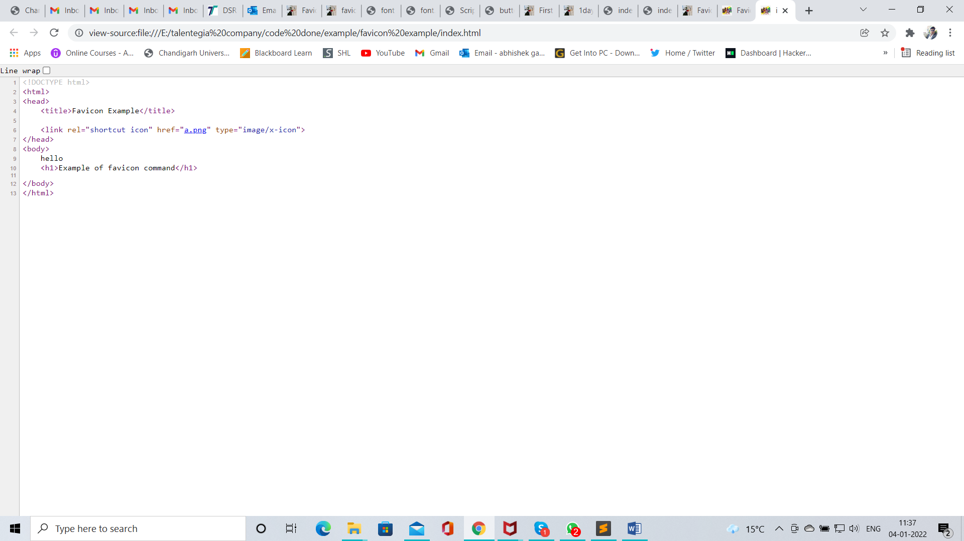

Figure 2 code to use faviconwhen image in same folder

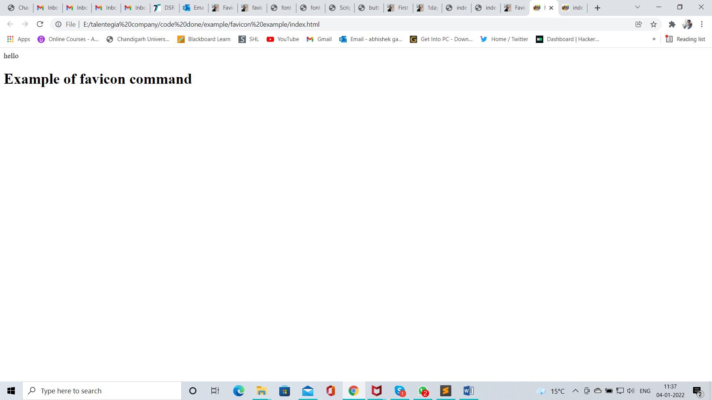

Figure 3 Favicon image 1

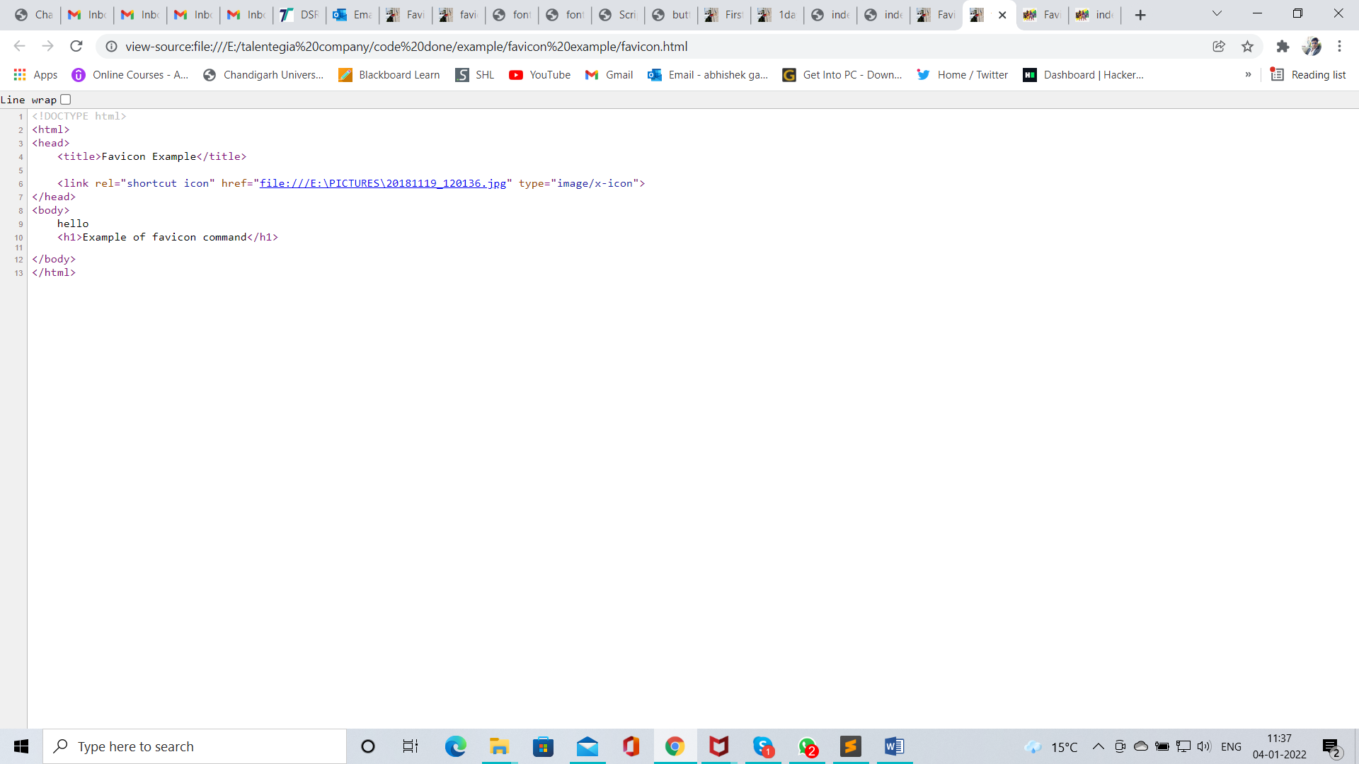

Figure 4 code of favicon when image is in different folder

## <meta/> tag

* Meta data is data about data.
* Metadata is not displayed on web page but it can be machine parsable (understandable).
* <meta/> tag provides metadata about html document
* Meta Attributes
  + Meta keywords
  + Meta description
  + Meta author
  + Meta title
  + Meta charset
  + Meta viewport

## <style>

* It is used to apply styles to html documents
* It is a paired tag.
* Code

<!DOCTYPE html>

<html>

<!-- this is a head section -->

<head>

<title>font example</title>

<style>

p{

color: red;

font-family: candara;

font-size: 50px;

}

body{

background-color: black;

}

h1{

color: black;

font-family: lucida calligraphy;

font-size: 120px;

text-shadow: 0px 0px 5px red;

}

</style>

</head>

<!-- this is a body section -->

<body>

<p>Wlecome</p>

<h1>Font example</h1>

</body>

</html>

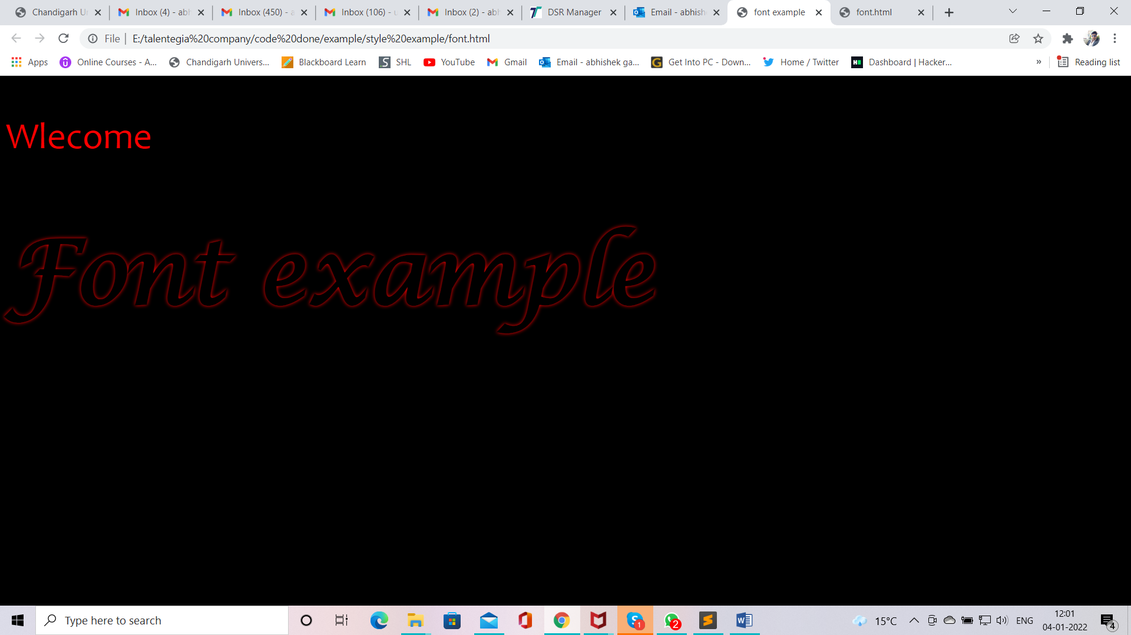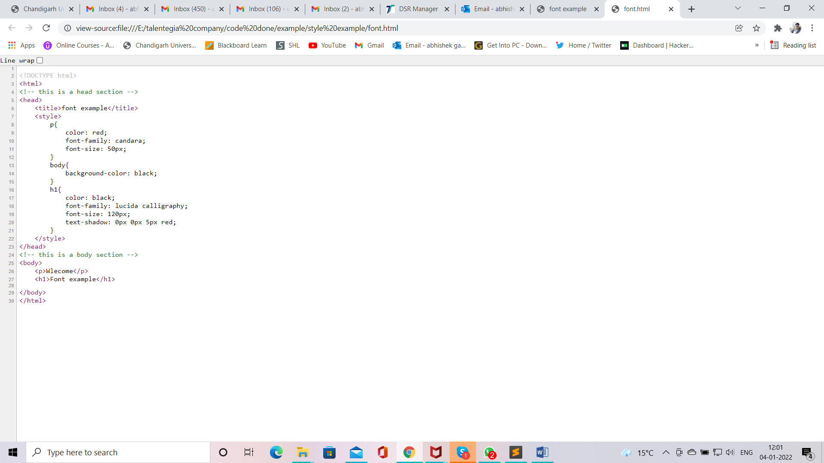

Figure 5 style web page

Figure 6 style code

## <script>

* It is a paired tag.
* It is used to apply script to html page.
* Code

<!DOCTYPE html>

<html>

<!-- this is a head section -->

<head>

<title>Script demo</title>

<script type="text/javascript" language="javascript">

function myAlert()

{

alert("button clicked")

}

</script>

</head>

<!-- this is a body section -->

<body>

<h1></h1>

<p></p>

<button on onclick="myAlert()">click me</button>

</body>

</html>

## Body section

* It contains <body> tag as root elements
* This section contains contents of html document, such as text, hyperlinks, images, special characters, lists, forms etc.
* <body> is paired tag.
  + Attributes parameters
  + Background image path
  + Bgcolor color name/ code
  + Text color name/ code

#### Color codes

* Html color are defined in 24bit RGB values.
* These values are represented in hexadecimal forms.
* Values start with #
* 0 is the lowest values.
* F is the largest/highest value
* R G B color name color code
* #FF FF FF WHITE #FFFFFF
* #00 00 00 BLACK #000000
* #FF 00 00 RED #FF0000
* #00 FF 00 GREEN #00FF00
* #00 00 FF BLUE #0000FF

#### HTML 5 special character(Entities)

* Character entities can be typed as either numbered entity or named entity
* All entities begin with ‘&’ and end with ‘;’
* E.g. &copy; &reg; &trade;
* &#169; &#174; &#8482;
* Website link <http://www.columbia.edu/kermit/ucs2.html>
* But code should be in hexadecimal form
* Code is

<!DOCTYPE html>

<html>

<!-- this is a head section -->

<head>

<title>Html enities</title>

<!-- this is a meta section -->

<meta charset="UTF-8">

<meta name="description" content="">

<meta name="keywords" content="">

<meta name="author" content="">

<meta name="viewport" content="width=device-width, initial-scale=1.0">

</head>

<!-- this is a body section -->

<body>

<p>&copy; &reg; &trade;</p>

<p>&#169; &#174; &#8482; &#2315; &#176;</p>

</body>

</html>

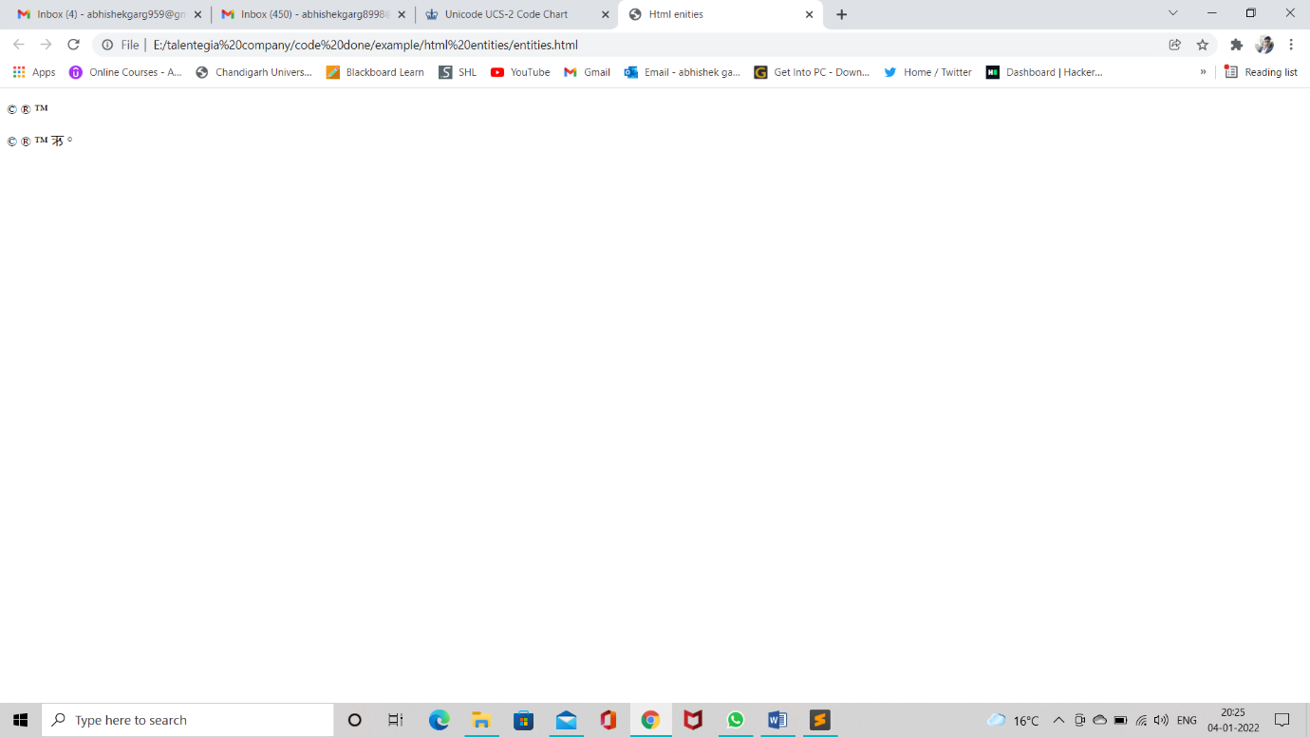

Figure 11 Enitities web site

#### HTML Headings

* In HTML there are six type of heading tags.
* H1,H2,H3,H4,H5,H6
* All Headings tags are paired tags.
* Attributes Parameters
* Align left, center, right

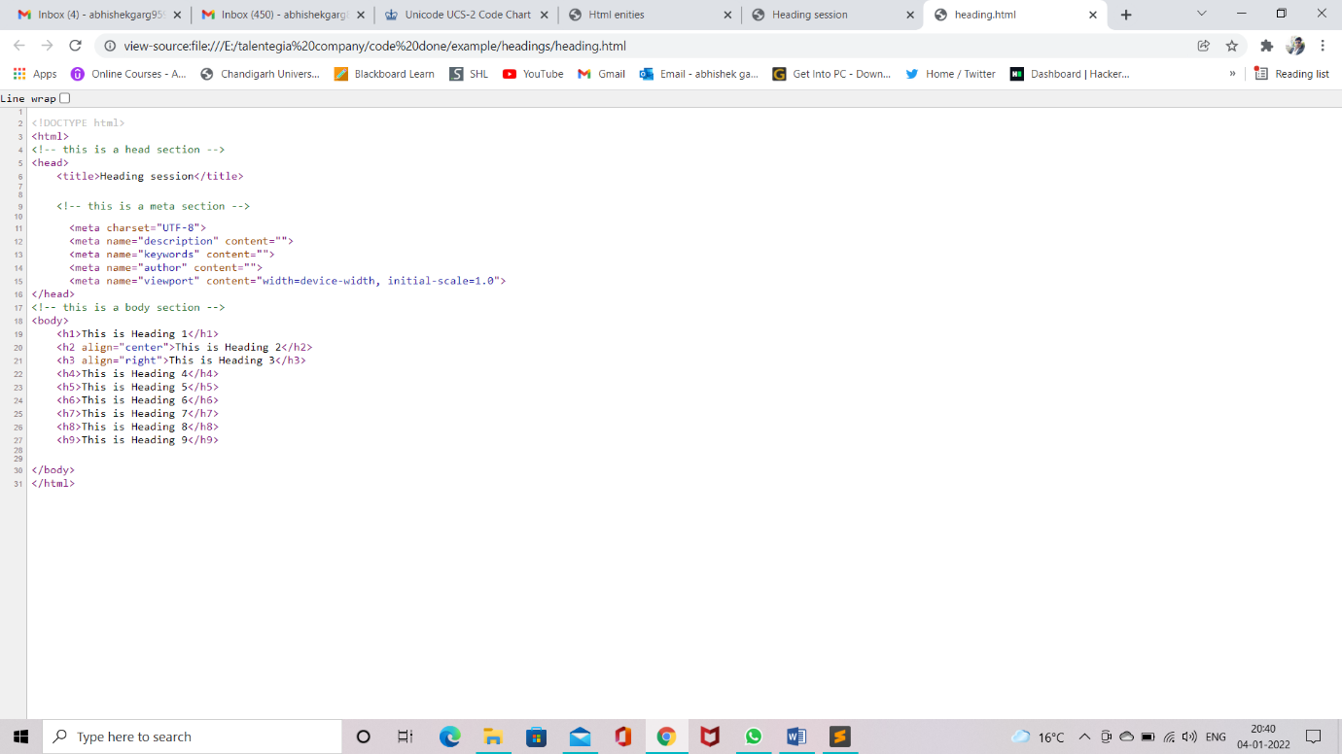

Figure 12 Heading code snip

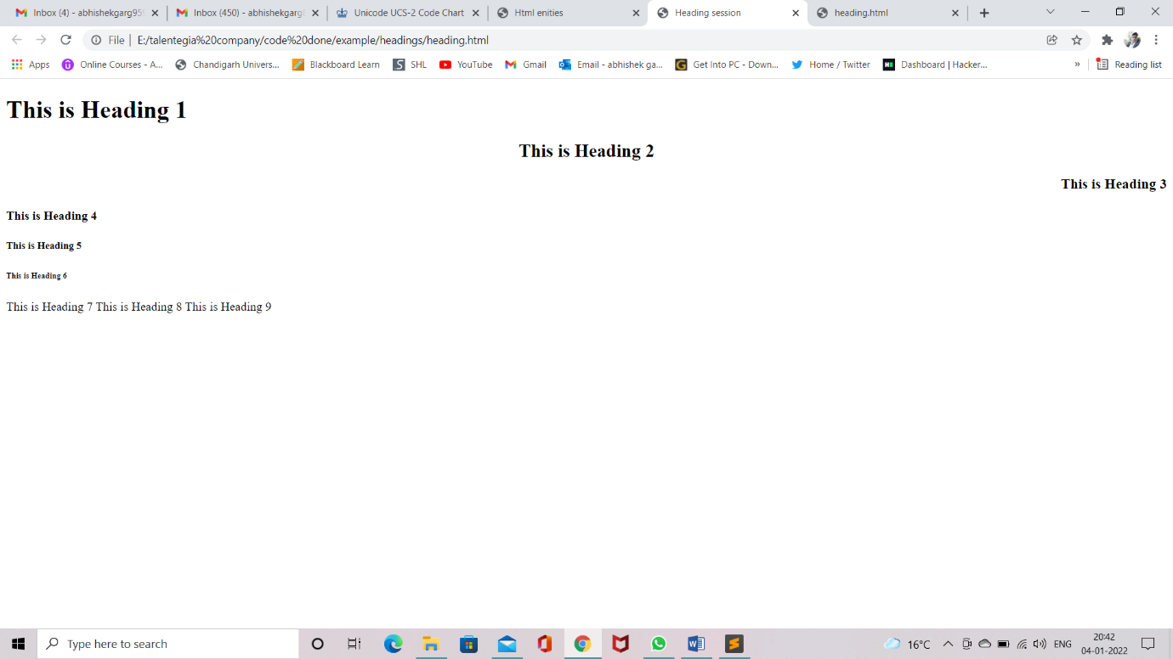

Figure 13 Heading Website view

#### HTML Paragraph(<p> tag)

* It is used to divide text into different paragraphs.
* It is a paired tags.
* Attributes Parameters
* Align left, right,center,justify

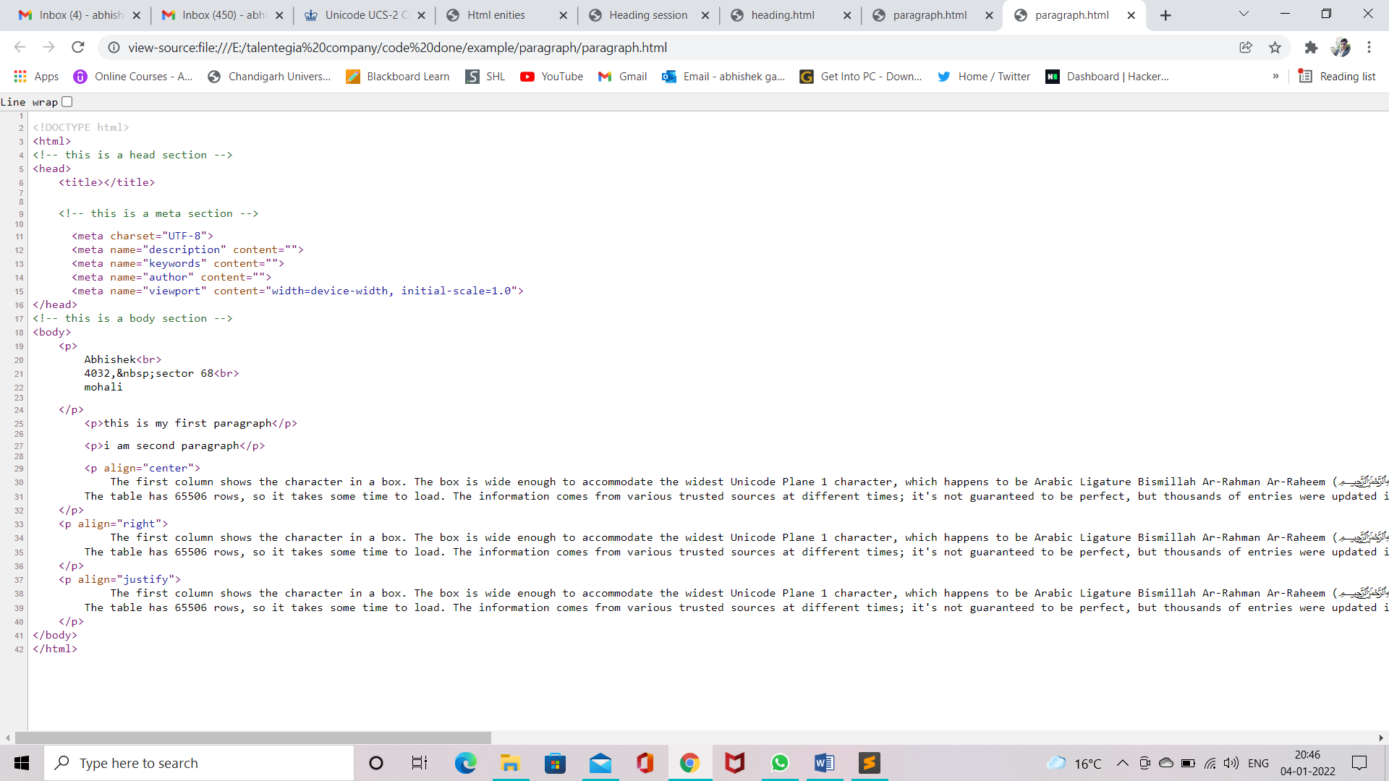

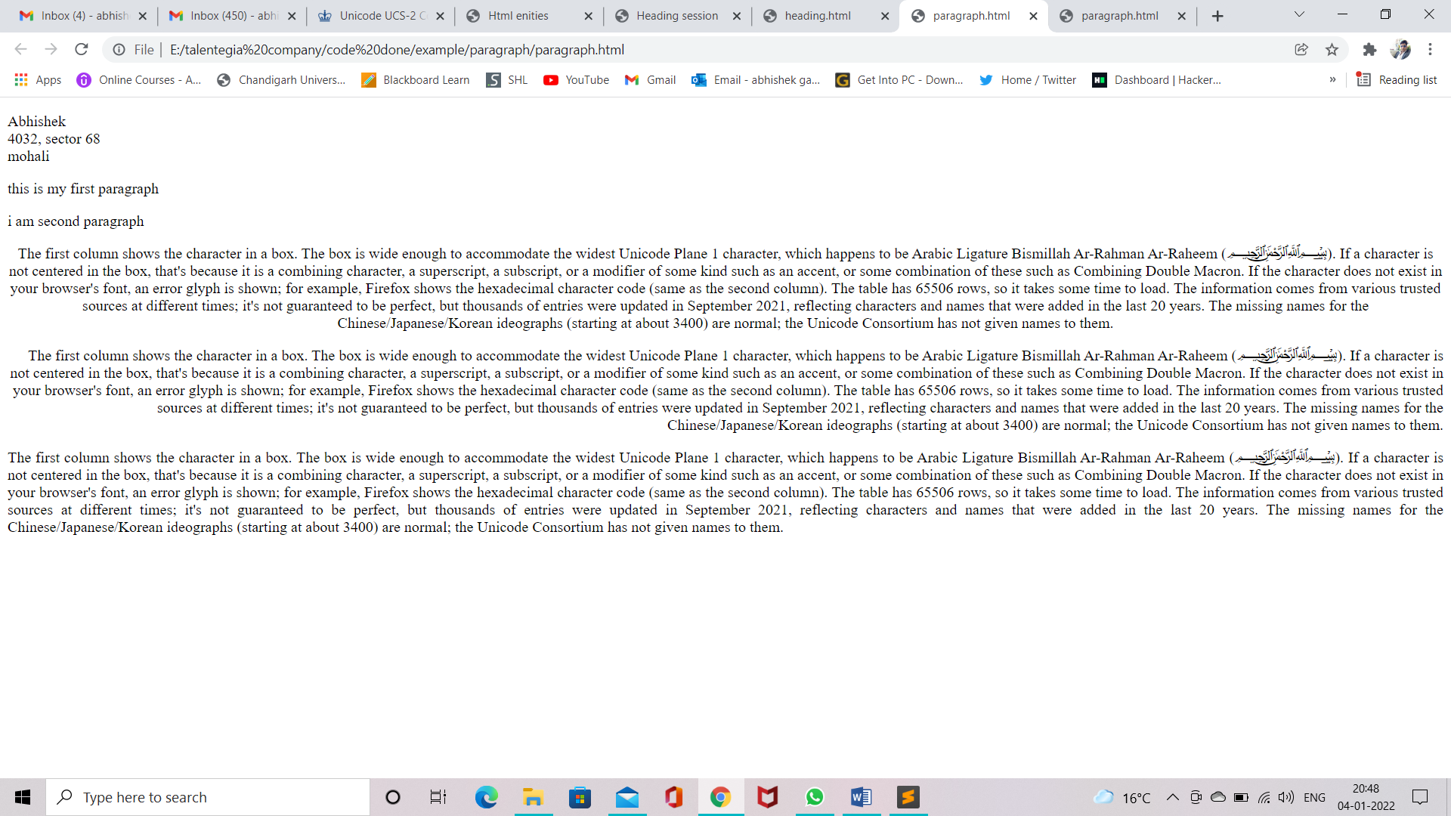

Figure 14 Paragraph web snip

Figure 15 Paragraph code

#### Line Brake(<br> tag)

* <br> stands for breaks.
* It is used to break a line and shift following text to next line.
* It is a non-paired tag.

#### Non-Breaking Space (&nbsp;)

* It is used to insert more than one spaces.
* It is special character entity

#### HTML Horizontal rule(<hr> tag)

* This tag is used to draw a line across the web page.
* It is a non-paired tag.
* Attribute Parameters
* Color color name/code
* Size px
* Width % / px
* Align left, center, right
* Noshade noshade

Note :- Noshade is working with only noshade not with color names.

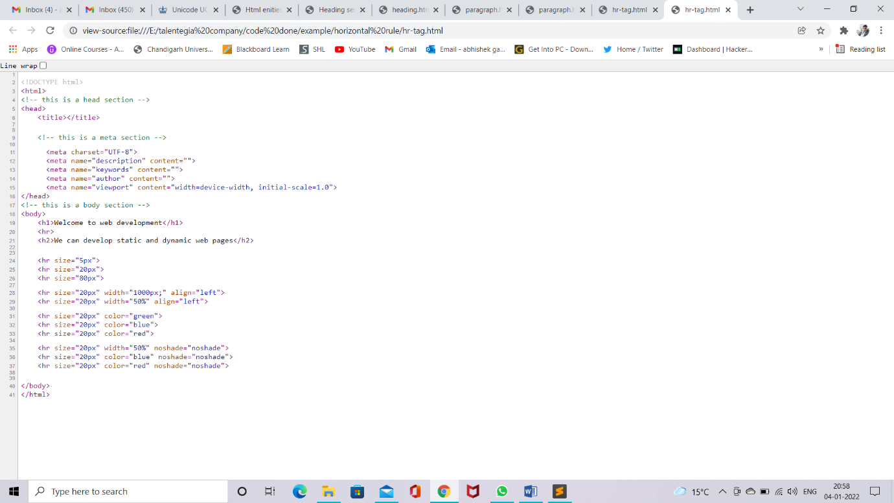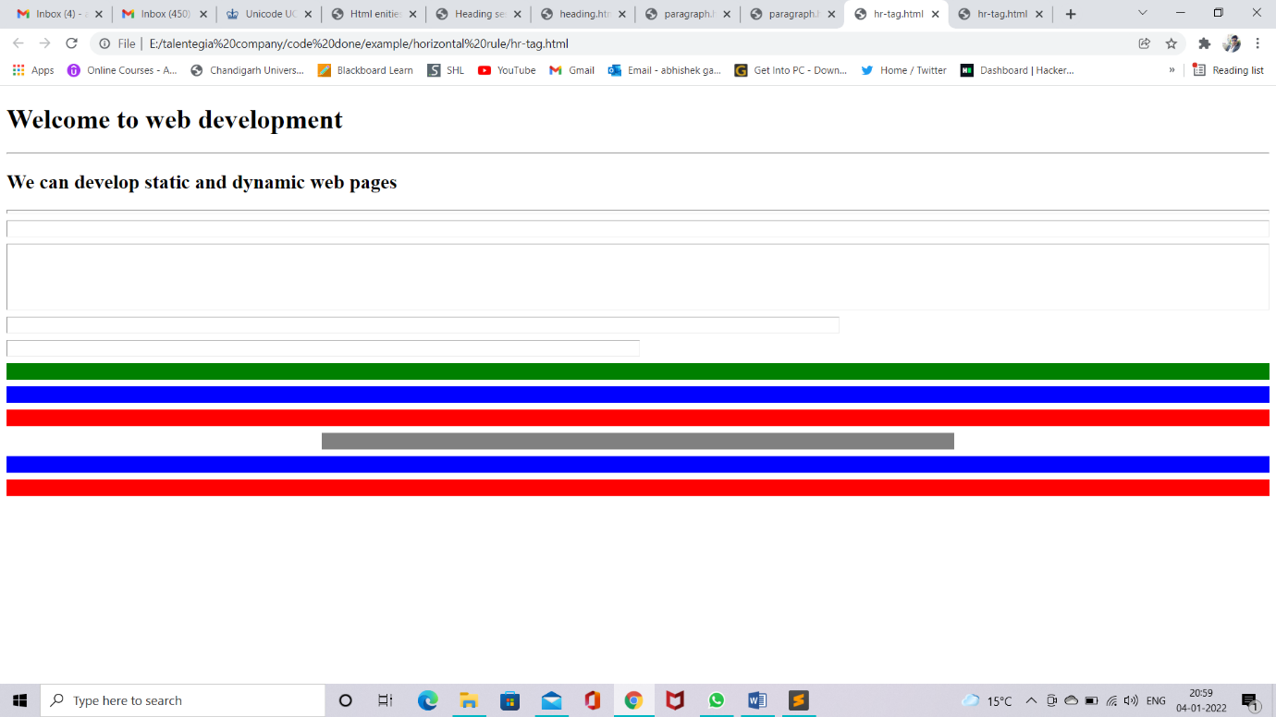

Figure 16 hr tag code

Figure 17 hr tag website snipt

#### User Inputs

* To accept inputs from user, generally we use forms.

###### HTML forms(<form> tag)

* This tag defines a form that is used to collect user inputs.
* It is a paired tag.
* Form Attributes
* Method
* Action
* Target
* Encrypt
* <input /> tag
  + Attributes Parameters
  + Name any name
  + Value any value
  + Size px
  + Max length number
  + Rows number
  + Cols number
  + Readonly true/false
  + Disabled disabled
  + Checked checked
  + 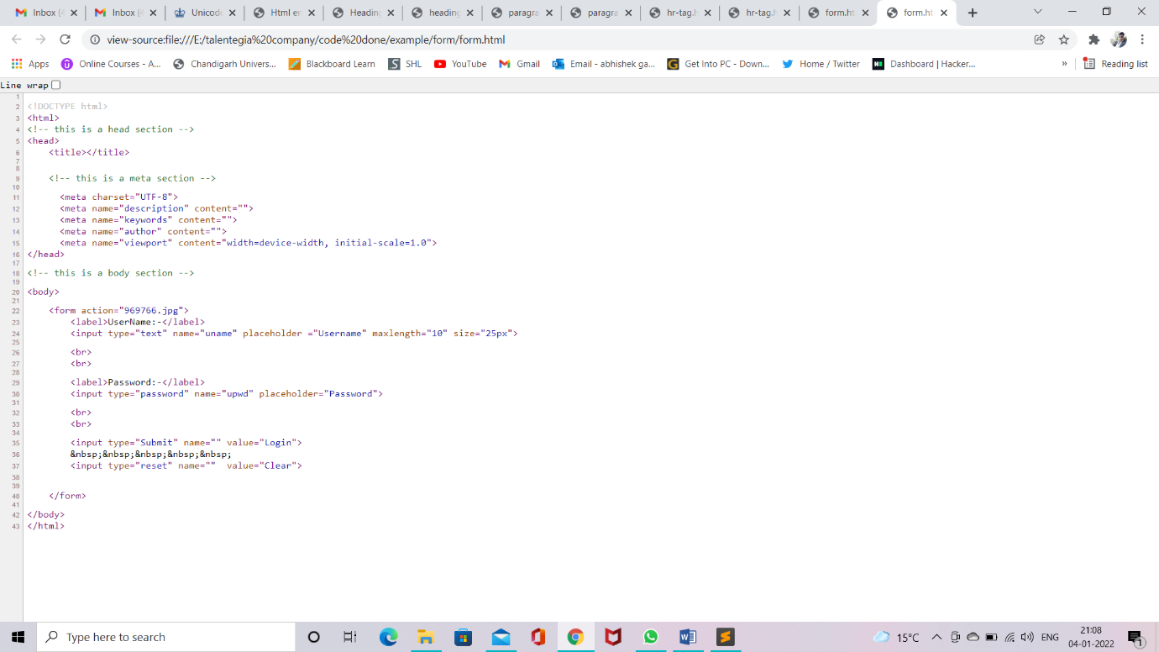Multiple true/false

Figure 19 form code

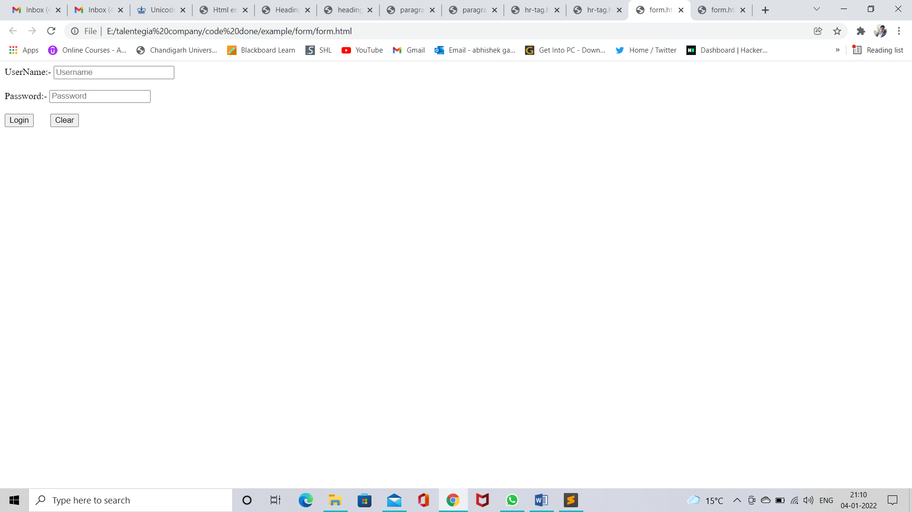

Figure 18 form web look

###### Textarea(<textarea>)

* Multiple textbox
* <textarea rows=”5” cols=”45”>…</textarea>

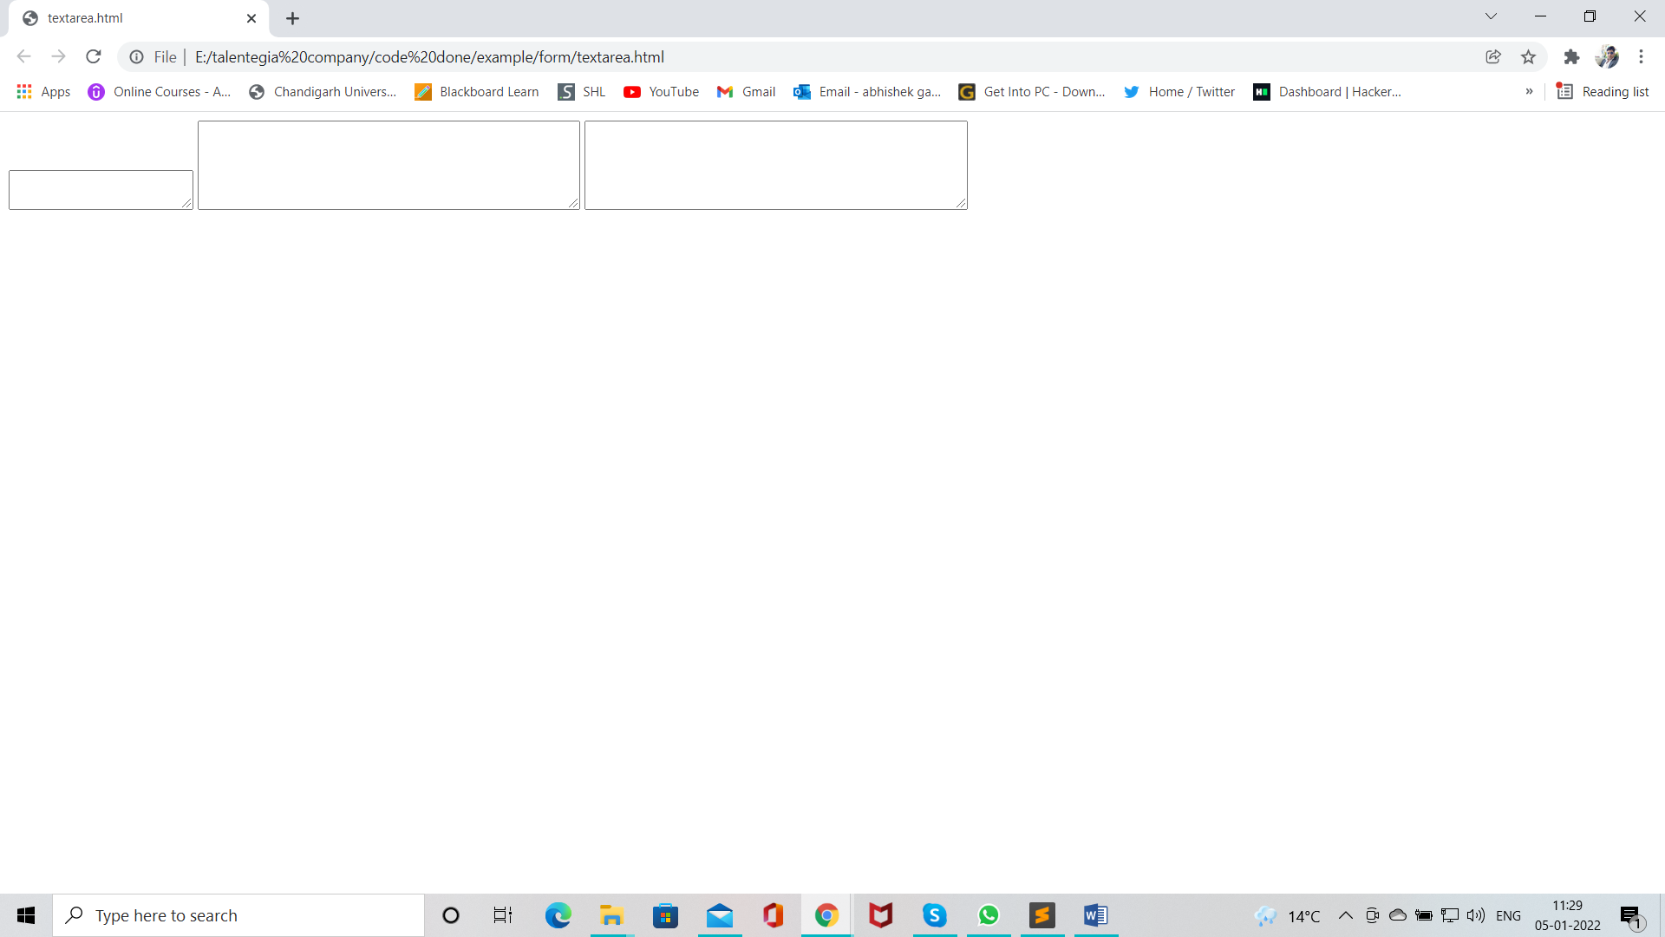

Figure 20 textarea web snipt

###### Dropdown list tag

* <select> tag is used to create dropdown list
* <option> tag inside select element define the available option in the list.
* <select> and <option> both tag are paired tag.

<select> tag

* Attributes Parameters
* Disabled disabled
* Multiple multiple
* Size number(number of visible option)

<option> tag

* Attribute Parameters
* Disabled disabled
* Label text
* Selected selected
* Value text

<optgroup>tag

* It is used to group logically related option in the dropdown list
* For longlist options group of related options are easier for user to handle.
  + Attributes Parameters
  + Disabled disabled
  + Label text

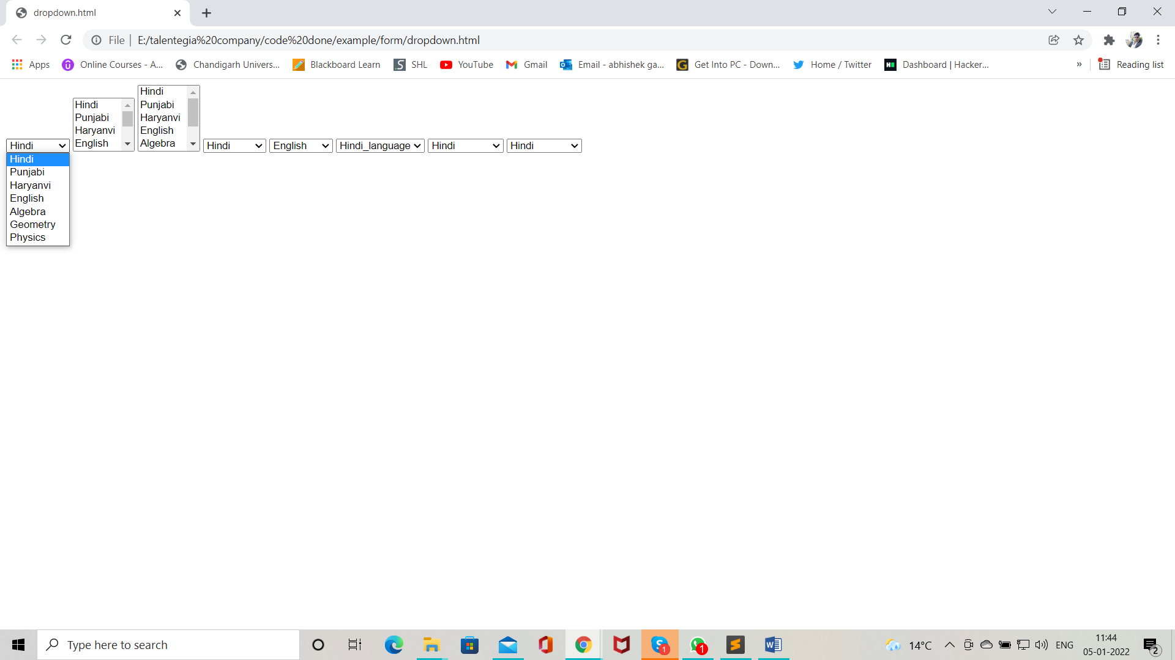

Figure 21 dropdown list web snipt

#### Radio control

* Radio buttons are used when out of many options just one option required to be selected
* This are created using HTML input tag ( type = “radio” )

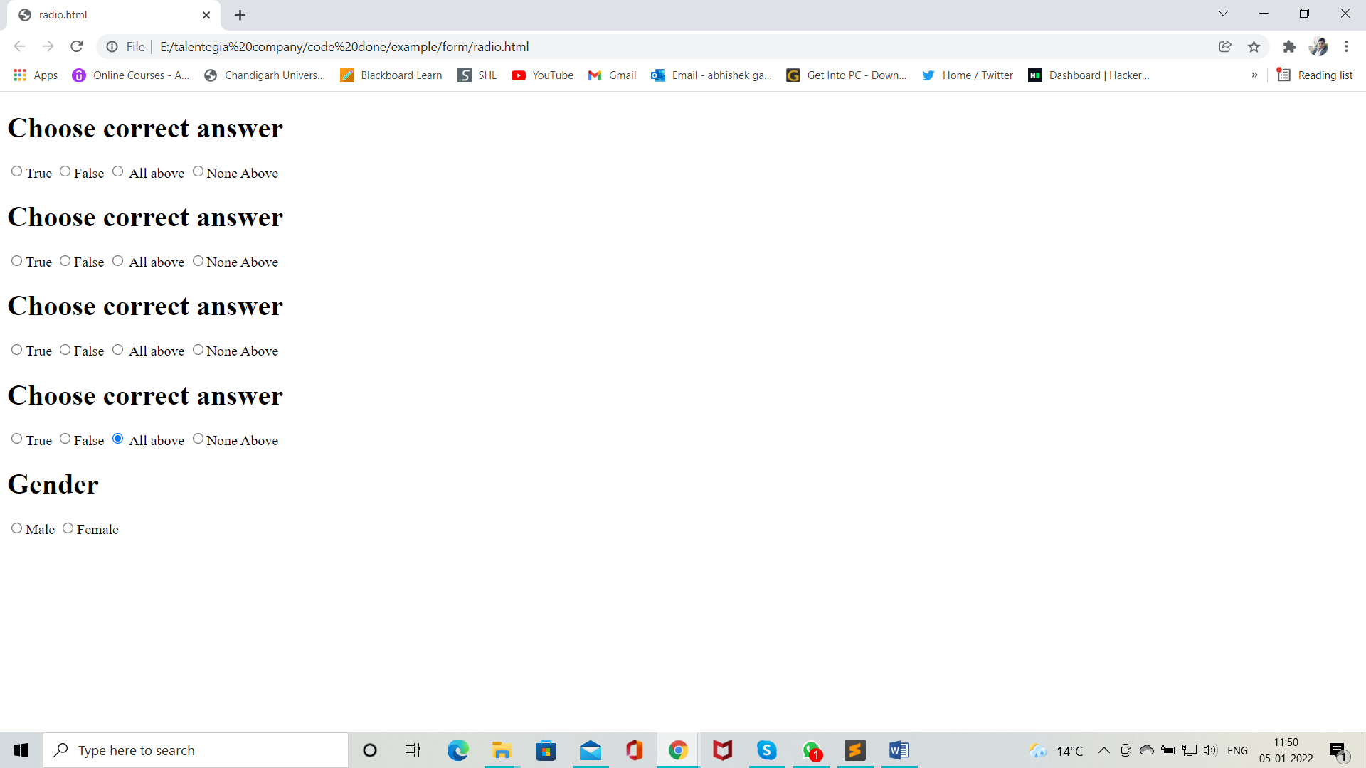

Figure 22 radio web snipt

#### Checkbox

* Checkboxes are used when more than one options are required
* These are created using HTML input tag (type = “checkbox”)

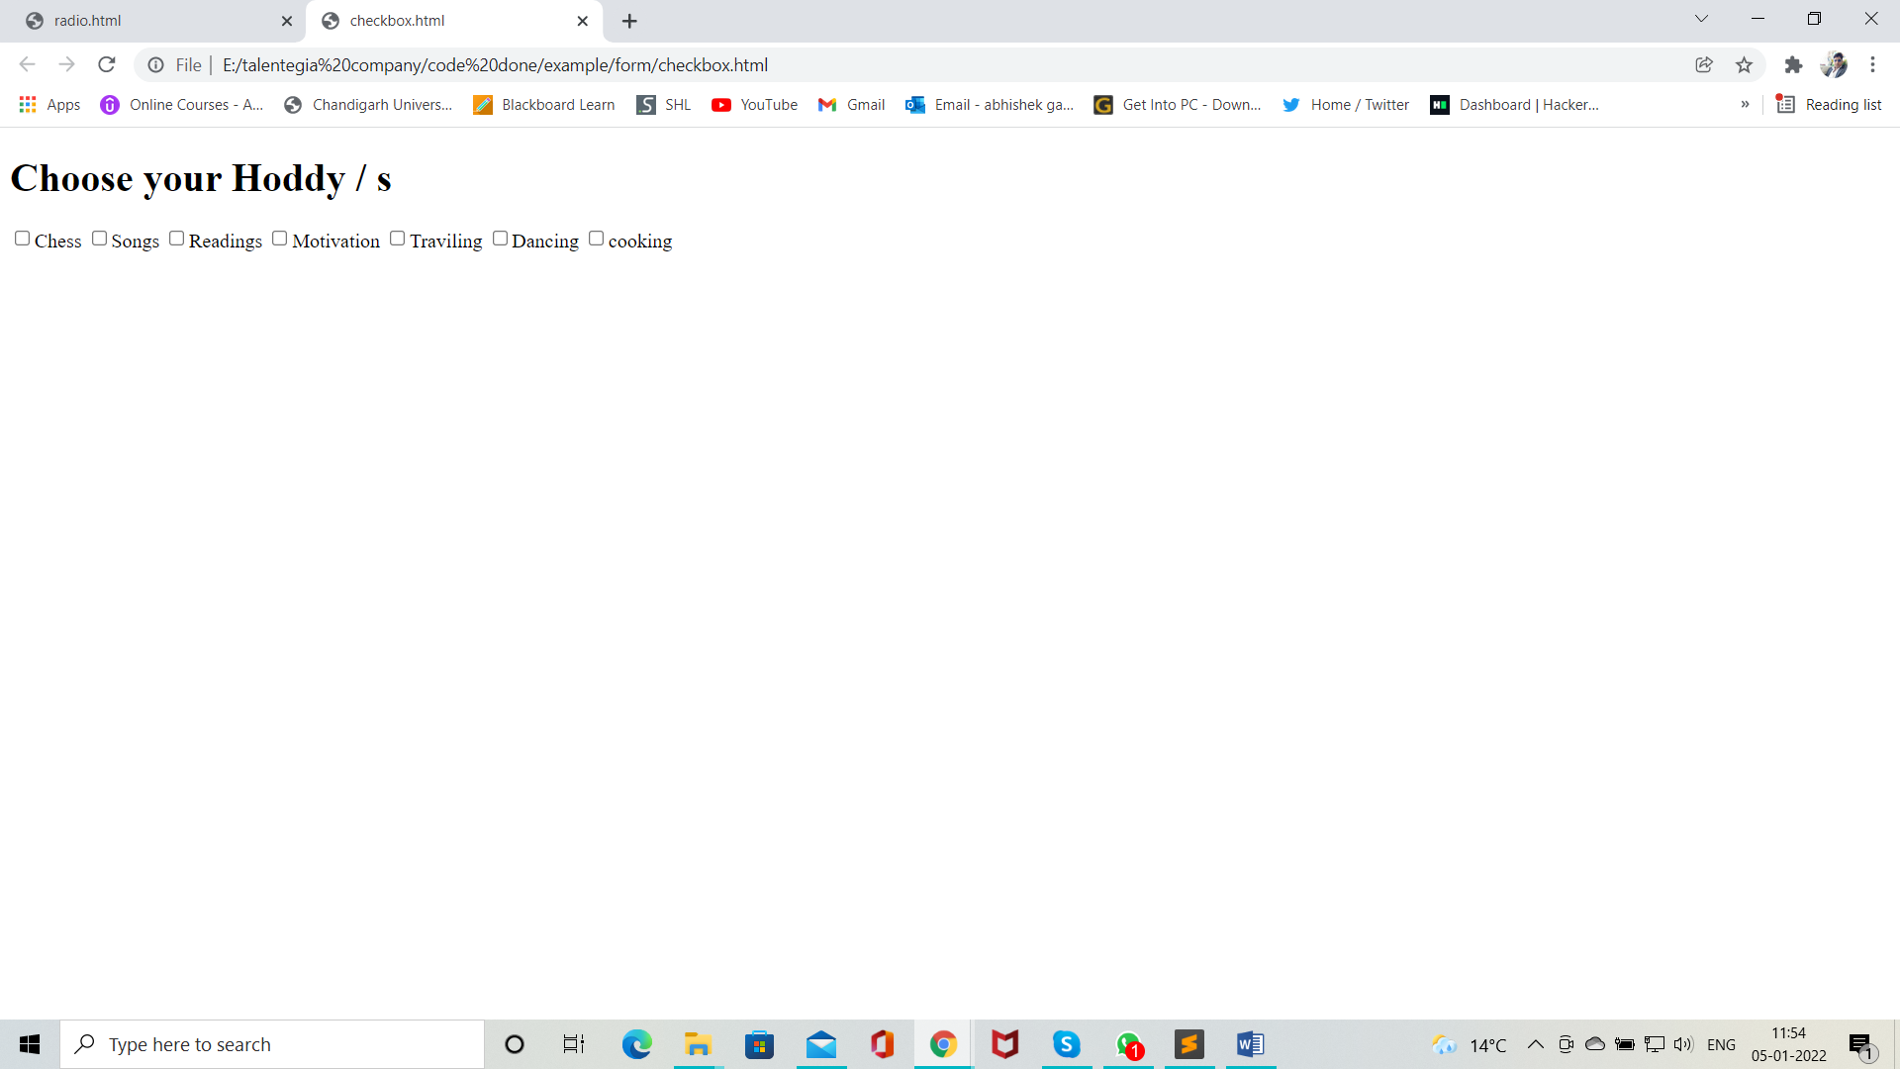

Figure 23 checkbox web snipt

#### <Fieldset>

* It defines group of logically related elements
* Elements are grouped inside a box
* It is a paired tag

#### <legend>

* It is used with field set to give title to each set of fields
* It is a paired tag.
* Attributes Parameters
* Align right, left, center

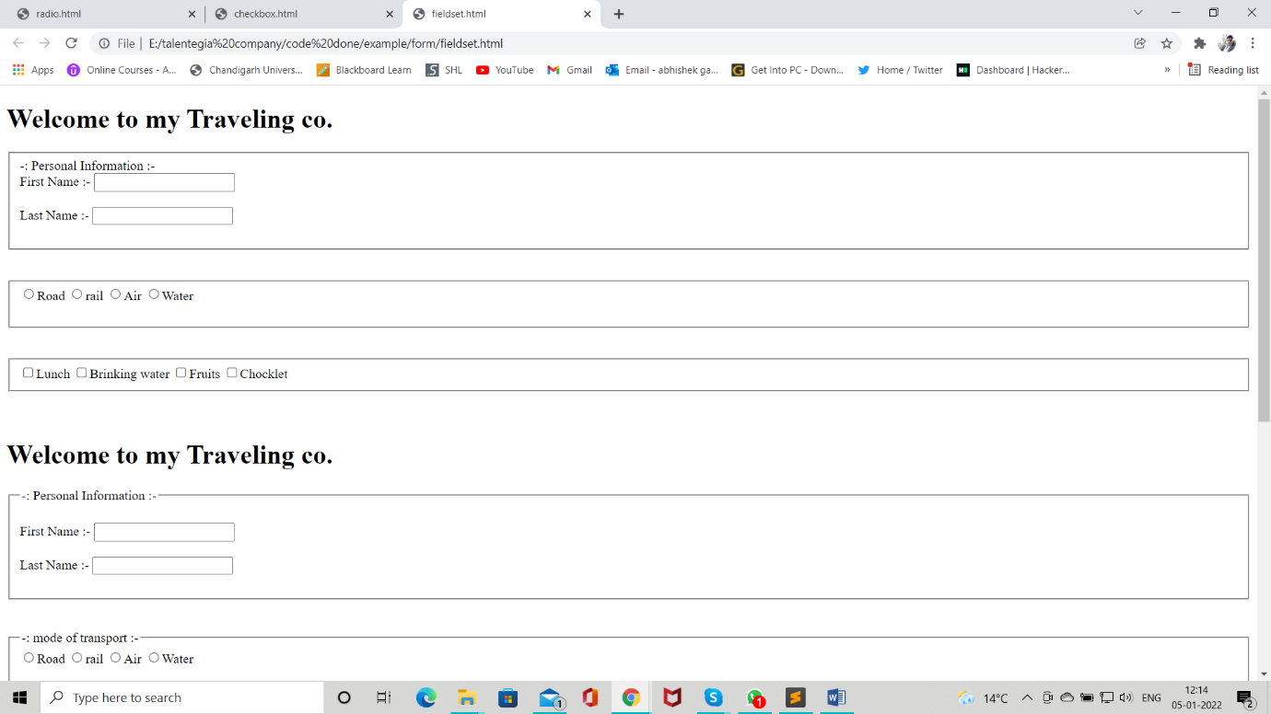

Figure 24 Legend and Fieldset web sinpt 1

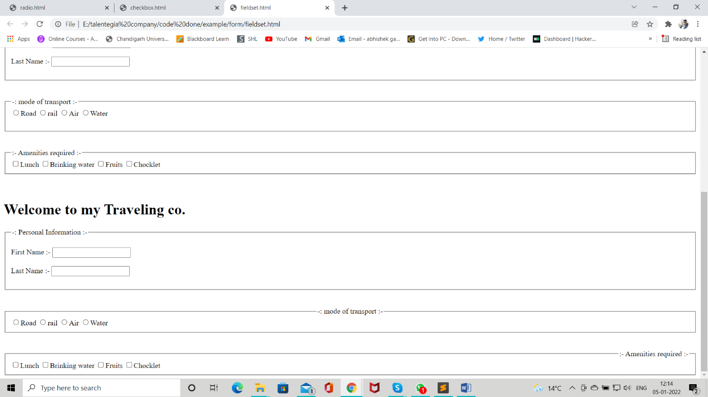

Figure 25 Legend and Fieldset web sinpt 2

#### HTTP ( Hypertext Transfer Protocol )

* It is used to enable/establish communication between client and server
* HTTP works as request-response protocol between client and server
* A web browser is client
* The computer who hosts the website is server

###### HTTP request methods

* There are various methods of HTTP requests
* E.g. GET, POST, PUT, UPDATE, DELETE, CONNECT, … etc.
* Of which two methods are commonly used for request – response between client and server.
  + Get method
  + Post method

###### Action Attribute

* This attribute is used to specify url of the server page to which we want to send our form data.

Get Methods

* In this methods there is no security for data.
* This methods can send only limited data(2MB)
* It can carry row data from client to server.
* Notes:-
* GET requests can be cached.
* GET remain in browser history.
* GET requests can be bookmarked.
* GET requests should not deal with sensitive data.
* GET requests length is rest recited.
* GET requests have excellent performance
* GET requests cannot upload images.

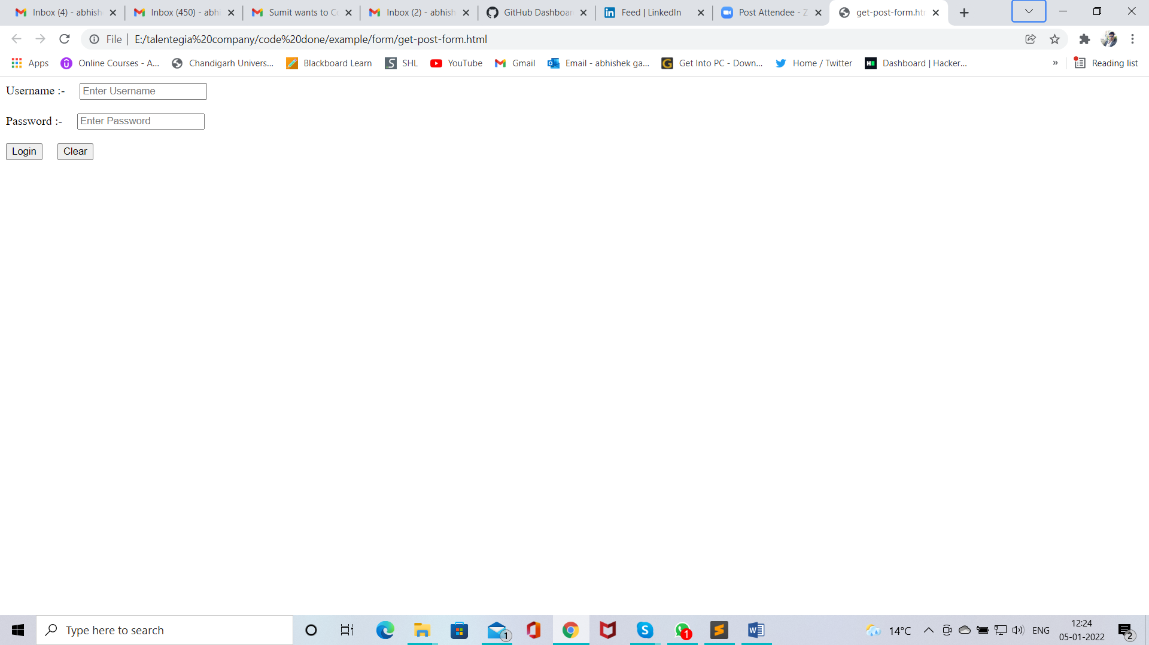

Figure 26 get web snipt 1

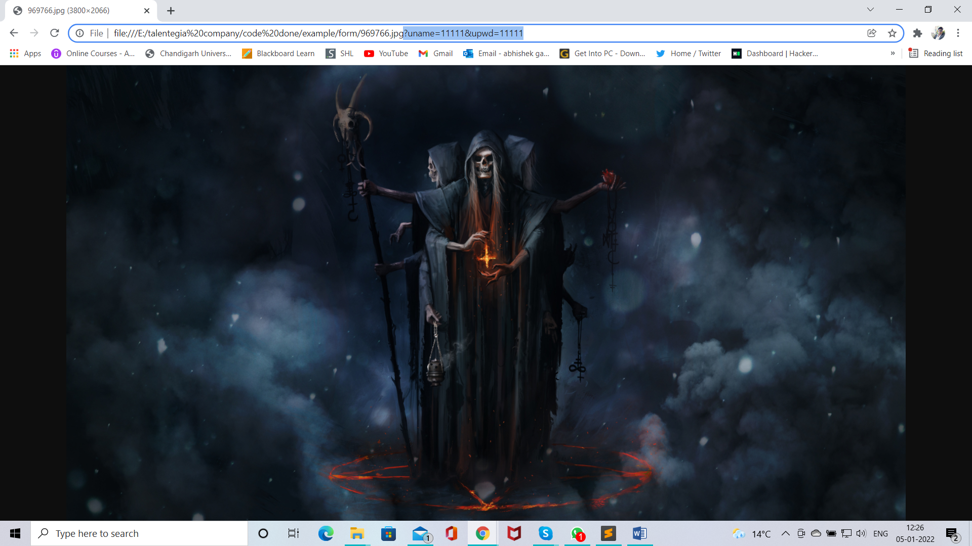

Figure 27 get web site snipt 2

POST request

* In this method we have security for data.
* This method can send bulk of data.
* It can carry encrypted data from client to server.
* Notes:-
* Post requests cannot be cached.
* Post requests do not remain in browser history.
* Post requests cannot be bookmarked.
* Post requests can be deal with sensitive data.
* Post requests have no limit for data.
* Post requests have good performance.
* Post requests can upload images.

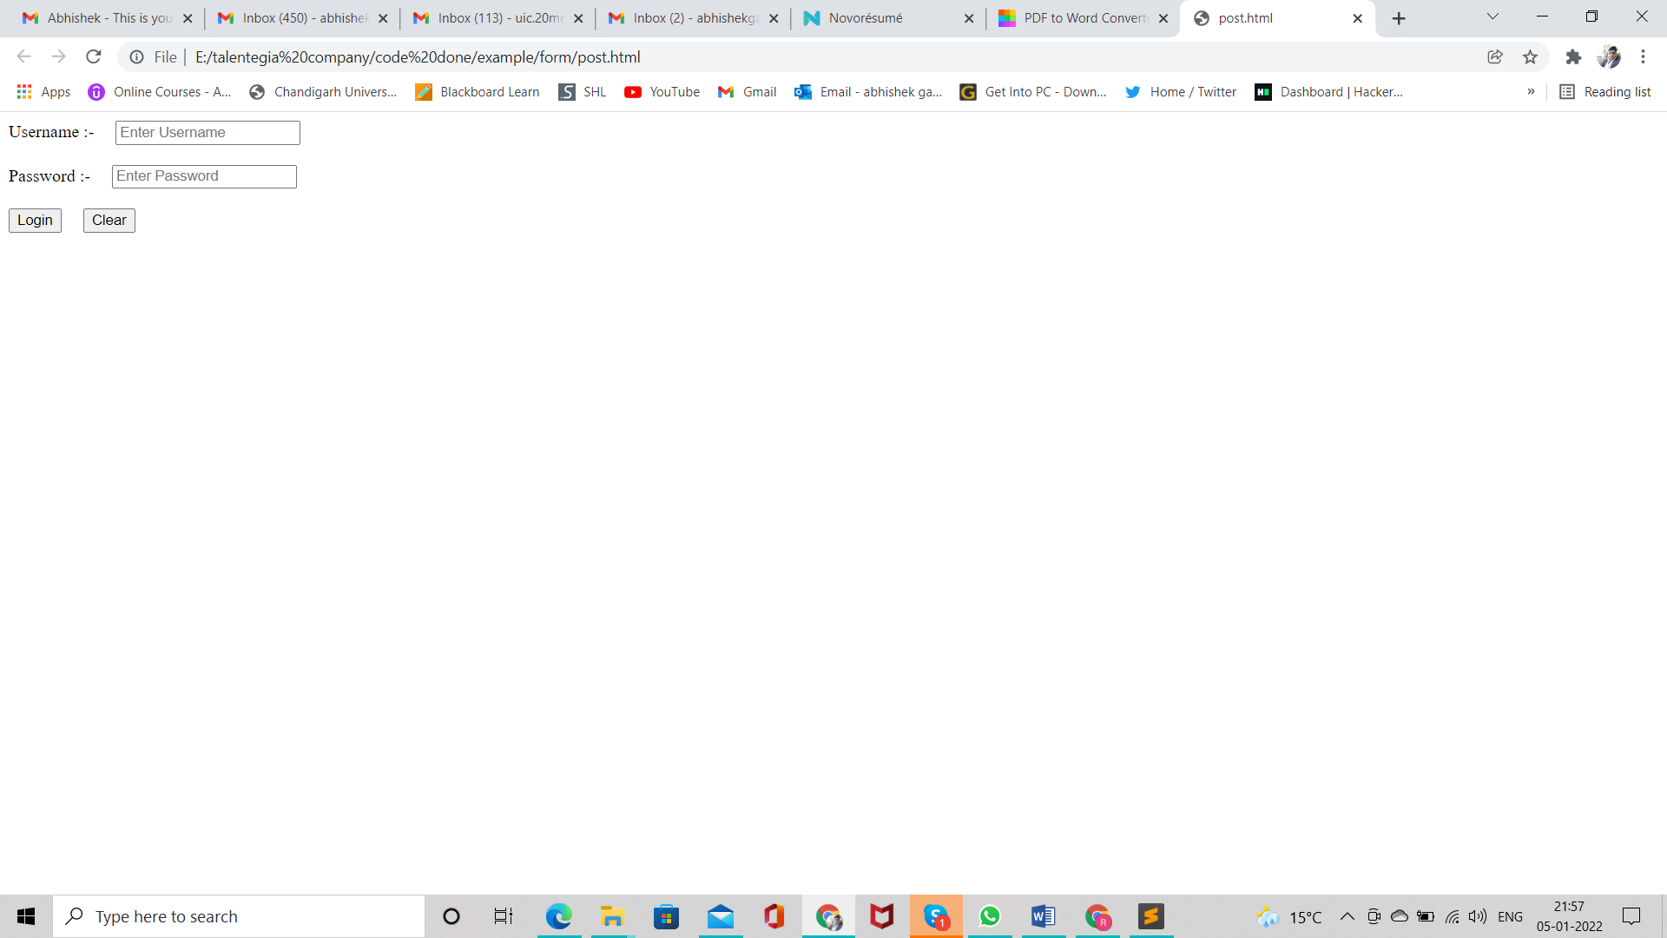

Figure 28 post web snipt 1

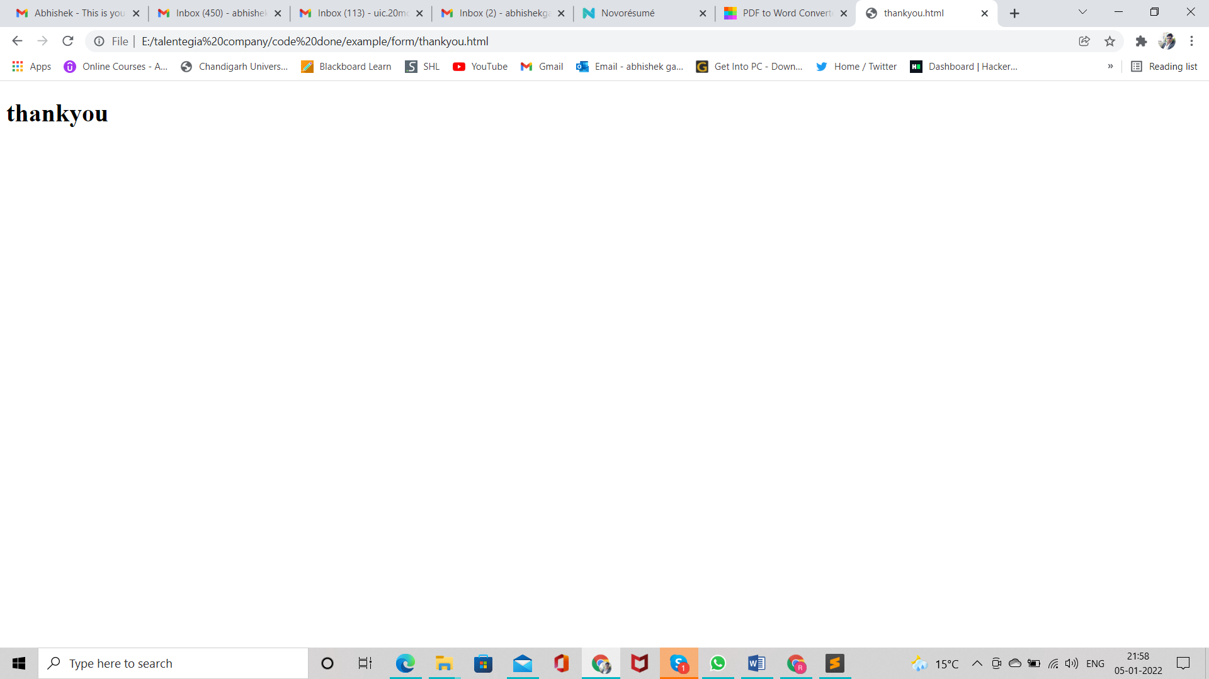

Figure 29 post web snipt 2

###### HTTP Status message / Code

* 1xx 100 to 199 information
* 2xx 200 to 299 Success full
* 3xx 300 to 399 Redirection
* 4xx 400 to 499 Client side errors
* 5xx 500 to 599 Server side errors

###### HTML Images

* To insert image on HTML page <img /> tag is used.
* It is non-paired tag.
* Attributes Parameters
* Align left, right
* Border px
* Height px / %
* Width px / %
* Src URL(Uniform resource Locator)
* Note:- for responsive we used % in place of px. Because % automatically adjust his length and width according to device.

###### Anchor tag ( a tag)

* It defines hyperlinks, which is used to link resources from one page to another page.
* It is a paired tag.
* Attributes Parameters
* Href URL
* Target blank(open new page)
  + - * Parent(stay on same page)

###### Lists in HTML

* There are three types of lists in html
  + Ordered list <ol> <li></li> </ol>
  + Unordered list <ul> <li></li> </ul>
  + Definition list <dl> <dt> <dd>

Ordered list <ol>

* It is also called as numbered list.
* It is used to give numbering to list items
* Attributes Parameters
* Type I, i , a , A, 1
* Start any number

Unordered list

* It is also called as bulleted list
* It is used to give bullets to list items
* Attributes Parameters
* Type disc, circle, and square.

Nested List

* List inside the list is called the Nested list

Definition list

* It is also called as Descriptive list.
* It is used to give definitions to definition terms.
* <dt> is used to specify definition term.
* <dd> is used to specify definition data/description.

###### HTML Presentational Tags

<blockquote>

It specifies a section that is quoted from another source.

<pre> or <xmp>

It is preformatted text.

<sub>

It displays subscript.

<sup>

It displays superscript

<b> or <strong>

It uses to bold the text.

<small>

It uses to small the text.

<i> or <em>

It uses to italic the text

<u>

It uses to underline the text.

###### HTML Tables

* Tables are used to represent data in tabular form.
* Tables are created using <table> tag.
* Table rows are represented using <tr> tag.
* Table cells (data) represented using <td> tag.
* Table is divided into two section head and body.
  + Table head is represented using <thead> tag.
  + Table body is represented using <tbody> tag.
* Attributes Parameters
* Border pixels
* Bordercolor color
* Bgcolor color
* Background image
* Height px / %
* Width px / %
* Align left, right, center
* Valign top, bottom, middle
* Rules rows, cols, all, none
* Cellspacing px
* Cellpadding px
* Rowspan number
* Colspan number

###### Span Tag

* It is used to apply inline styles on some specific span

###### Div

* By using this tag we can divided a webpage as multiple divisions.
* Attributes Parameters
* Align left, right, center

###### Other inputes

* Color
* Date
* Month
* Week
* Time
* file

###### <marquee>

* it is a scrolling piece of text,image, or any other content of web page.
* It scrolls in either horizontal or vertical direction.
* In general this tag is not used, instead CSS, JS etc. used to create such effects.
* Attributes Parameters
* Width % / px
* Height % / px
* Direction up, down, left, right
* Behaviour scroll, slide, alternate
* Scrolldelay number ( by default 85ms)
* Scrollamount number ( by default 6px)
* Loop number ( by default infinity)
* Bgcolor color
* Hspace %
* Vspace %

###### HTML 5 new Tags

<article> It defines the independent or self-contained content of a webpage.

<aside> It defines the content which provide information about the main content.

<bdi> It is used to isolate the part of text which might be formatted in another direction.

<details> It defines additional information which only visible as per user demand.

<dialog> It represents a dialog box or other interactive components.

<figcaption> It defines caption for the <figure> element.

<figure> It defines a self-contained content, and referenced as a single unit.

<footer> It represents the footer section of the webpage.

<header> It defines the introductory or navigational content of the webpage.

<main> It specifies the main content of the HTML document.

<mark> It represent the text which is highlighted or marked for reference or notation purposes.

<meter> It represents a scalar value within a known range.

<nav> It represents the section which contains navigation links.

<progress> It defines a progress bar which shows completions progress of a task.

<rp> It defines alternative content for the browser which do not support ruby annotations.

<rt> It defines explanations and pronunciations of characters in ruby annotations.

<ruby> It defines ruby annotations (Specifically for Asian language).

<section> It defines a generic section within an HTML document.

<summary> It defines summary or caption for a <details> element which can be clicked to change the state of <details> element.

<time> It defines data/time within an HTML document.

<wbr> It specifies a line break opportunity. (Where line break possible)

###### Graphics Tags

<canvas> It allows drawing graphics and animations via scripting.

<svg> It is used to draw scalable vector graphics.

###### HTML5 Media Tags

<audio> It defines sound content.

<embed> It defines a container for external files/application/media.

<source> It defines multiple media resources for the media elements.

<track> It defines text tracks for <audio> and <video> files

<video> It defines video content within HTML document.

###### HTML5 New Inputs

color Color selector, which could be represented by a wheel or swatch picker

date Selector for calendar date

datetime-local Date and time display, with no setting or indication for time zones

datetime Full date and time display, including a time zone.

email Input type should be an email.

month Selector for a month within a given year

number A field containing a numeric value only

range Numeric selector within a range of values, typically visualized as a slider

search Term to supply to a search engine. For example, the search bar atop a browser.

tel Input type should be telephone number.

time Time indicator and selector, with no time zone information

url Input type should be URL type.

week Selector for a week within a given year